**JavaScript Notes**

**Adding js file to html**

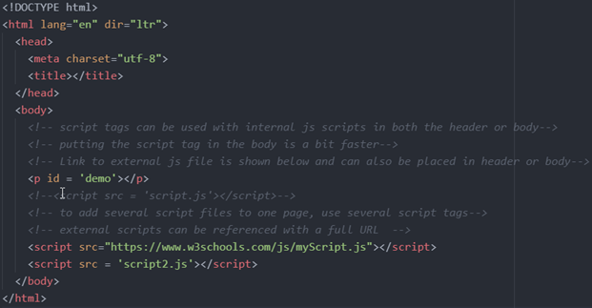

* The browser parses HTML from the top of the HTML file to the bottom as shown below. If the browser hits a resource such as an img or link, it will send out a request for that resource and continue parsing. Notice the browser does not stop parsing the HTML to get the img src.
* 
* Browsers render script tags differently. Instead of continuing to parse once a script tag is encountered, the browser instead stops parsing, downloads the JavaScript, and executes it (as shown below). This is why many times developers will put their script tags at the bottom of the HTML body so they do not delay the parsing of the HTML.
* 
* 
* You may see this and just think that putting script tags at the bottom of the HTML body is ideal, but if the HTML file is large then the JavaScript will not start downloading until all the HTML is parsed which could significantly delay the JavaScript download. This is why the async and defer attributes were created.
* Async:
  + To create an async script tag the following code is used <script async src="script.js"></script>. This attribute when applied to a script tag will make the script tag work just like img tags to the parser. This means the parser will download the JavaScript in the background and continue parsing as normal without waiting. When the JavaScript is done being downloaded then the parser will immediately stop parsing and execute the JavaScript. This is great for any small JavaScript code that is not dependent on anything else, but since the JavaScript is executed as soon as it is downloaded, the parser could still be delayed by JavaScript that takes a long time to execute. Another huge downside of the async attribute is that the JavaScript files are not executed in the order they are defined in the HTML. They are instead executed in the order they are downloaded. This means a quicker to download file will always execute before a slower to download file which can cause big problems if the JavaScript files are dependent on one another. Because of this, I rarely use async when loading script tags. The below video shows how the document is parsed when the async attribute is used.
  + 
* Defer:
  + Similar to the async attribute, the defer attribute will not stop parsing to download the JavaScript. To create a defer script tag the following code is used <script defer src="script.js"></script>. The parser will download the JavaScript in the background and continue parsing, but unlike the async attribute, the defer attribute will not execute the JavaScript until after the entire HTML document is parsed. This means that with the defer attribute the HTML parsing will never be delayed by the downloading of JavaScript. Also, since the JavaScript is executed after the entire HTML document is parsed the order of the JavaScript files is maintained. This is because all defer attribute JavaScript files must be downloaded before any of them can be executed. I can put my JavaScript in the head of my HTML so it starts downloading as soon as possible, and it also preserves the order of my JavaScript as if it was loaded without the defer attribute. Loading JavaScript with the defer attribute is essentially the same as loading JavaScript at the end of the body, but it will start the download sooner. Also, since the executing of the JavaScript is always done after the HTML is parsed, there is no need to wait for document ready events. The document will always be ready when a defer attributed script tag is executed.
  + 
* TLDR: use defer and put your script tag in the head.

**Comments**

Single Line Comments // and Multi-Line Comments /**/

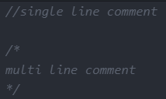

**Variables**

var

var declarations are globally scoped or function/locally scoped. If var variables are not declared a function, then it has global scope. In other words, this means any variable that is declared with var outside a function block is available for use in the whole window.

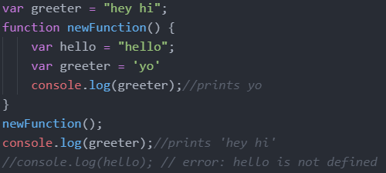

var variables can be re-declared and updated

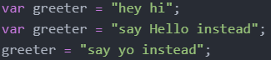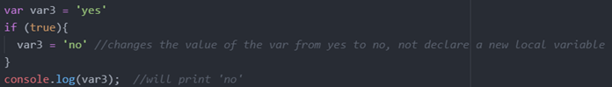

Hoisting of var. Hoisting is a JavaScript mechanism where variables and function declarations are moved to the top of their scope before code execution

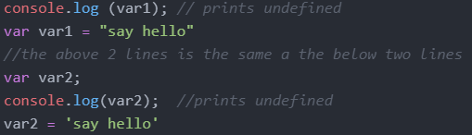

let

let is now preferred for variable declaration. let is blocked scope. a block is anything with {}When using let, you don't have to worry about if you have used a name for a variable before since a variable exists only within its scope. This fact makes let a better choice than var. Shadowing exists.

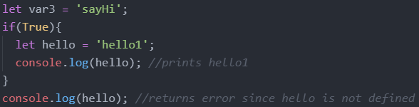

let can be updated but not re-declared

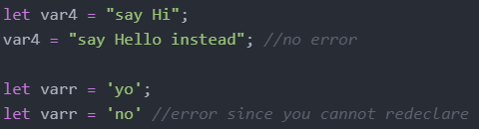

Hoisting of let. Just like var, let declarations are hoisted to the top. Unlike var which is initialized as undefined, the let keyword is not initialized. So if you try to use a let variable before declaration, you'll get a Reference Error

const

const definitions have block scope.Shadowing exists.

It does not define a constant value. It defines a constant reference to a value.



C prints out [1,2,3]

This is why we can change a const that takes on a mutable data type. The const variable takes on the memory address as its value which cannot change. But what is stored at the memory address can change.

Because of this you can NOT:

* Reassign a constant value
* Reassign a constant array
* Reassign a constant object



But you CAN:

* Change a constant array

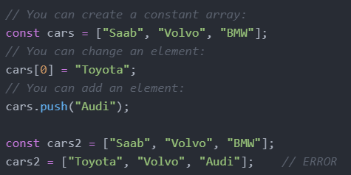

* Change a constant object

Declaring a variable with const is similar to let when it comes to Block Scope. The x declared in the block, in this example, is not the same as the x declared outside the block. Redeclaring a variable with const, in another scope, or in another block, is allowed

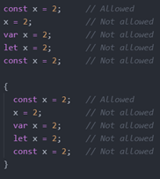

Hoisting, using a const variable before it is declared will result in a ReferenceError

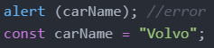

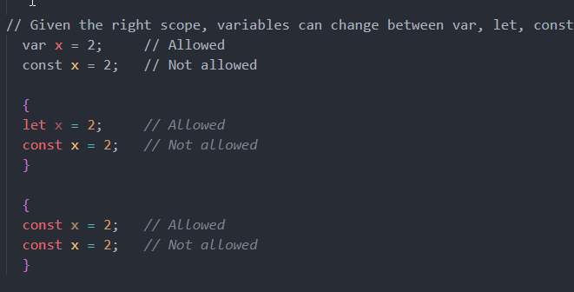

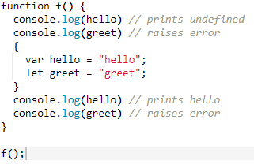

**Operators**

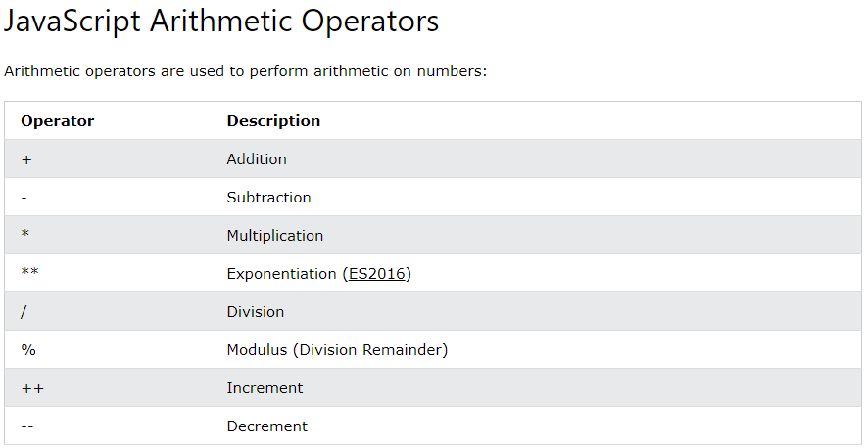

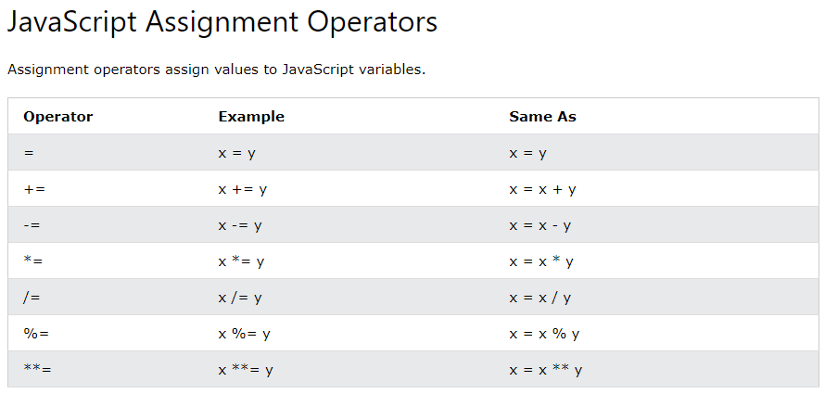

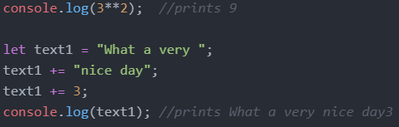

JavaScript evaluates expressions from left to right. Different sequences can produce different results:



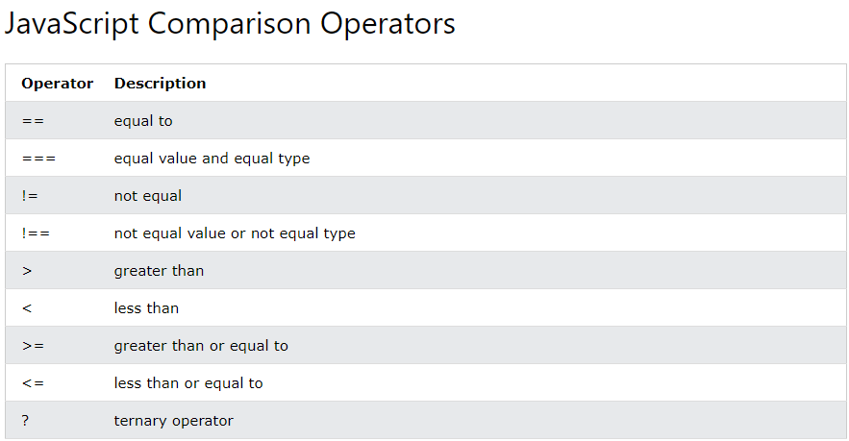

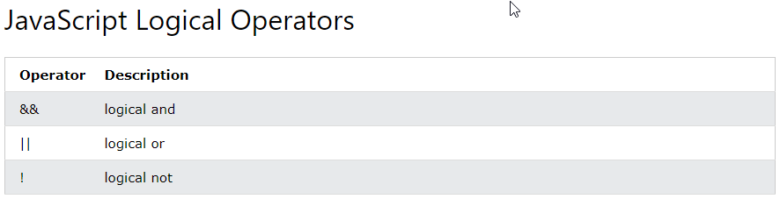

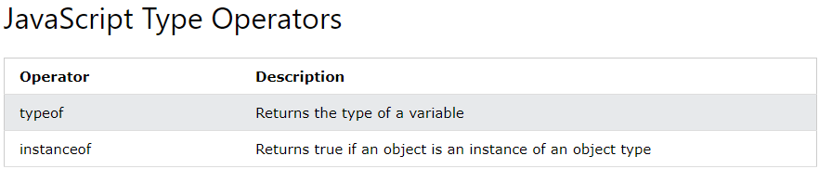

**Data Types**

Declaring Variables

Separated by semicolons, multiple statements on one line are allowed. The two codes below are the same.

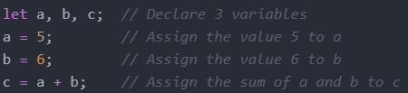



JavaScript has dynamic types. This means that the same variable can be used to hold different data types

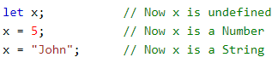

Undefined



Strings/Empty

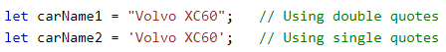

An empty value has nothing to do with undefined. An empty string has both a legal value and a type



Numbers

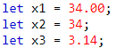

The above 3 variables will print as the following 3

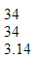

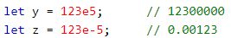

Booleans

let x = true;

let y = true;

Arrays



Objects

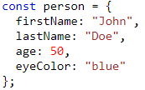

typeOf Operator



**Arrays**

Creating an Array

you can have variables of different types in the same Array such as objects, functions, arrays

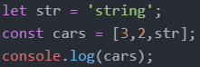



Accessing Array Elements

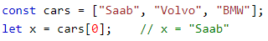

Changing Array Elements

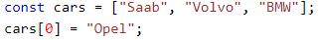

Access the Full Array

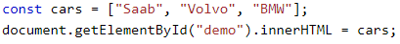

This will change demo to

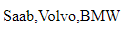

Adding Array Elements

The push() method add an element to the end of an the array



Adding large indexes can create holes

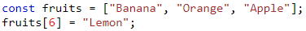

This will print the following

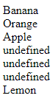

The unshift() method adds a new element to an array (at the beginning), and "unshifts" older elements:

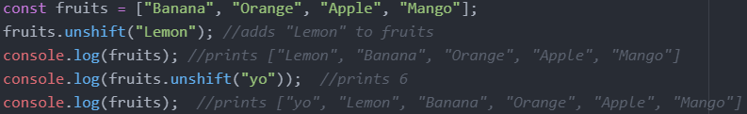

Remove Elements

The pop() method removes the last element from an array

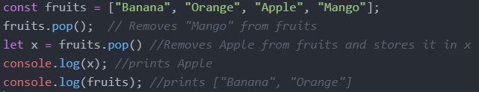

The shift() method removes the first array element and "shifts" all other elements to a lower index

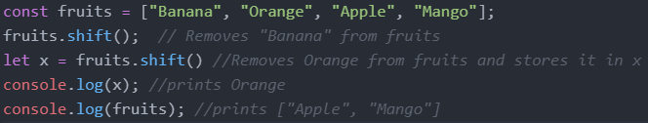

Length

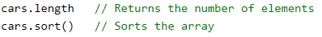

typeOf and Array.isArray() and instanceof

The problem is that the JavaScript operator typeof returns "object" for arrays

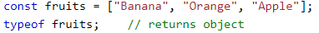

To solve this issue, we can use Array.isArray or instanceof





Convert Arrays to Strings

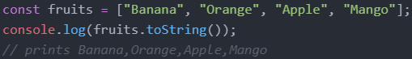

Splicing Arrays

The splice() method can be used to add new items to an array

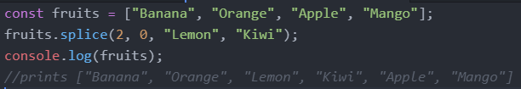

The first parameter (2) defines the position where new elements should be added (spliced in).

The second parameter (0) defines how many elements should be removed.

The rest of the parameters ("Lemon" , "Kiwi") define the new elements to be added.

Merging (Concatenating) Arrays

The concat() method creates a new array by merging (concatenating) existing arrays.

The concat() method does not change the existing arrays. It always returns a new array.

The concat() method can take any number of array arguments.

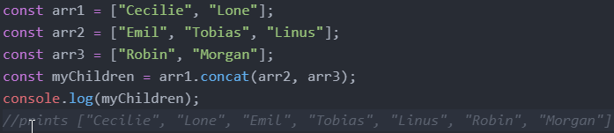

Slicing Arrays

The slice() method slices out a piece of an array into a new array.

The slice() method creates a new array. It does not remove any elements from the source array.

The slice() method can take two arguments and selects elements from the start argument, and up to (but not including) the end argument.

If the end argument is omitted, the slice() method slices out the rest of the array.

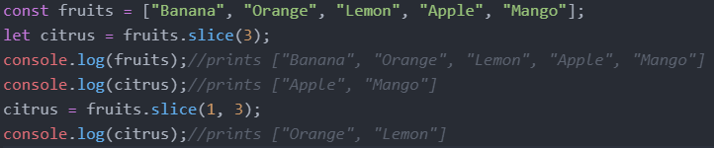

Sorting and Reversing Arrays

The sort() method sorts an array alphabetically for both strings and number elements

The reverse() method reverses the elements in an array by sorting in descending order:

Sorting Strings

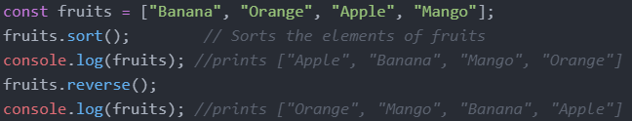

Sorting Numbers

By default, the sort() function sorts values as strings

If numbers are sorted as strings, "25" is bigger than "100", because "2" is bigger than "1".

Because of this, the sort() method will produce incorrect results when sorting numbers.

You can fix this by providing a compare function

Sort ascending: array_name.sort(function(a, b){return a - b})

Sort descending: array_name.sort(function(a, b){return b - a})

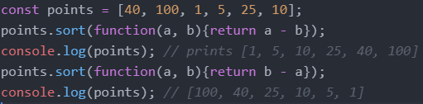

indexOf

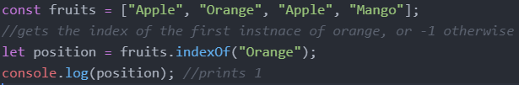

Array Iteration/ Array Methods

map()

The map() method creates a new array by performing a function on each array element.

The map() method does not execute the function for array elements without values.

The map() method does not change the original array

Syntax: array.map(function(currentValue, index, arr), thisValue)

Parameters:

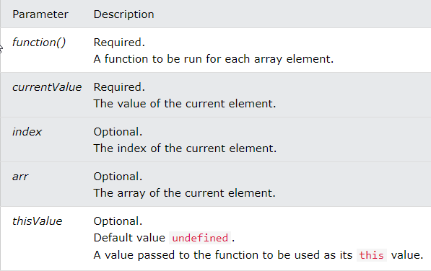

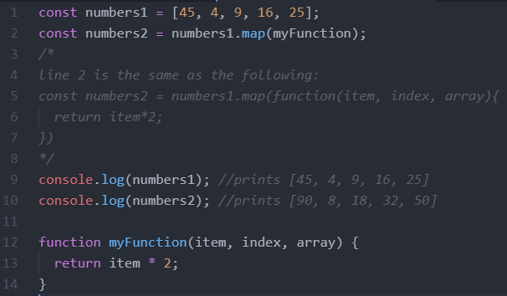

filter()

The filter() method creates a new array with array elements that passes a test. The parameter function returns true or false.

Filter does not change the original array.

Syntax: *array*.filter(function(currentValue, index, arr), thisValue)

Parameters:

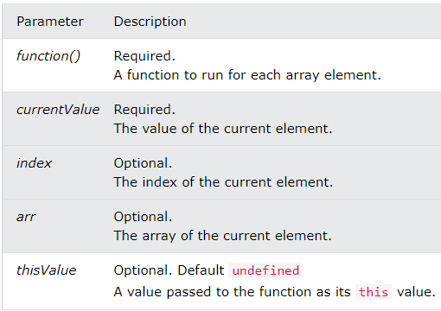

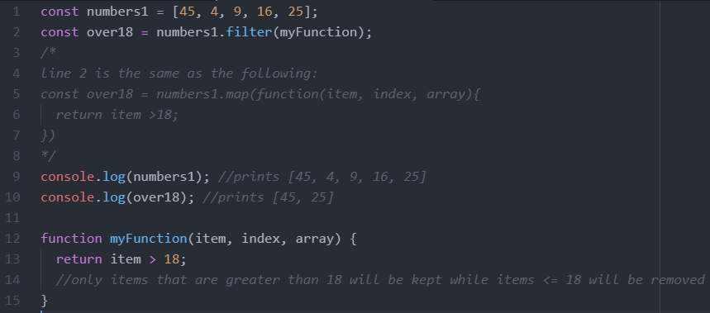

reduce()

The reduce() method runs a function on each array element to return a single value.

The reduce() method works from left-to-right in the array.

* Syntax: *array*.reduce(function(total, currentValue, currentIndex, arr), initialValue)
* Parameters:
* 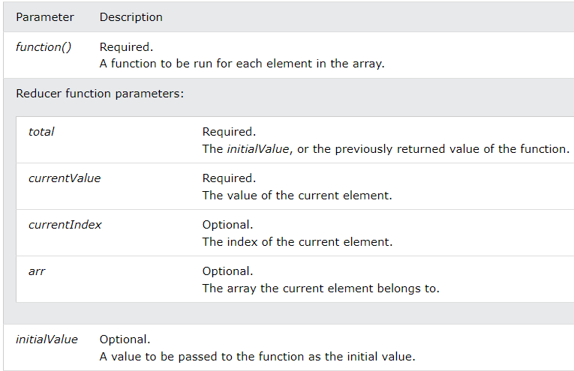

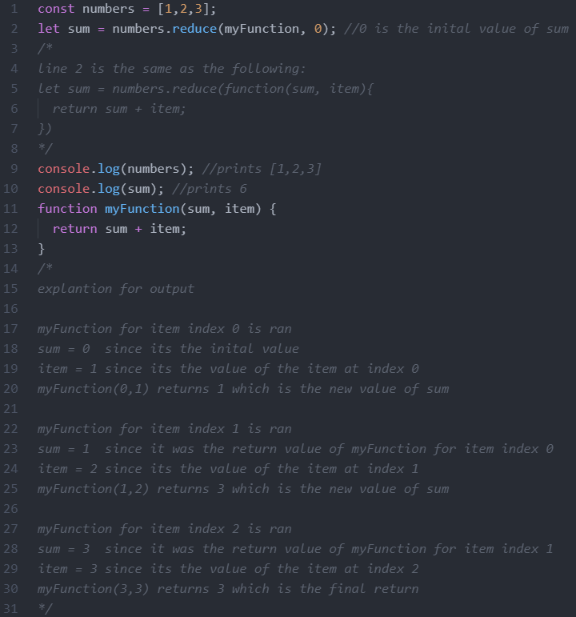

find()

The find() method returns the value of the first element that passes a test. The paramter function returns true or false.

Syntax: *array*.find(function(currentValue, index, arr),thisValue)

Parameters:

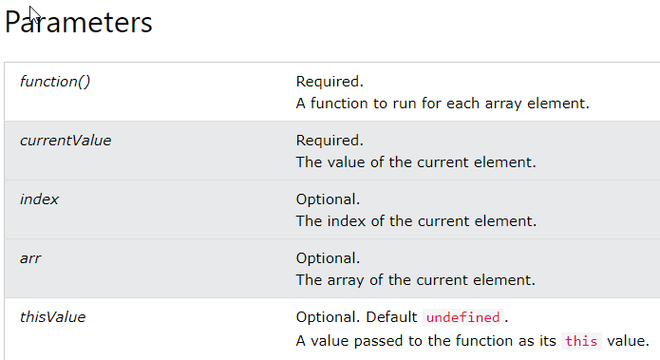

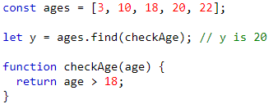

some()

* The some() method checks if any array elements pass a test (provided as a function). If at least one element passes a test, some() returns true. If all the elements fail the test, some() returns false.
* Syntax: *array*.some(function(value, index, arr), this)
* 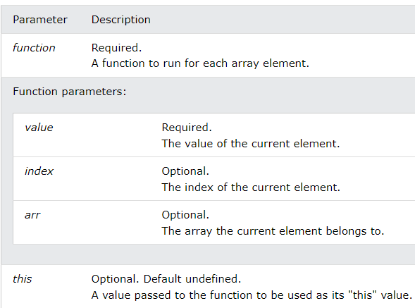

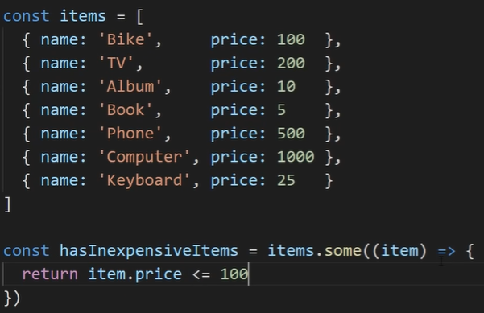

hasInexpensiveItems will be true in the above example since there is at least one element in the items array that has a price <=100

every()

* The every() method executes a function for each array element.
* The every() method returns true if the function returns true for all elements.
* The every() method returns false if the function returns false for at least one element.
* Syntax: *array*.every(function(currentValue, index, arr), thisValue)
* Parameters:
* 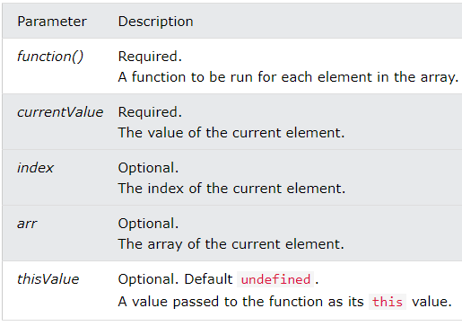
* 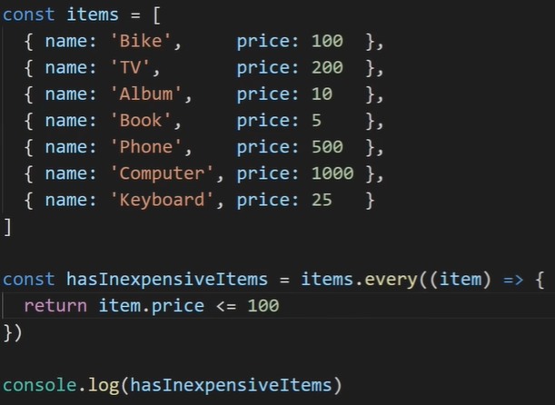
* The above prints false
* 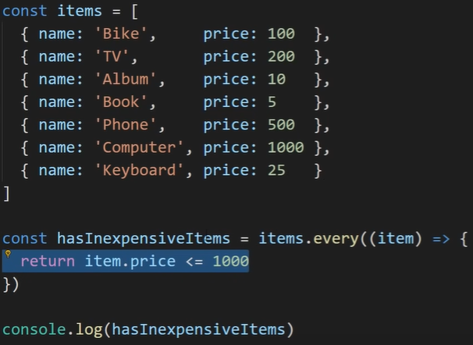
* The above prints true

includes()

* The includes() method returns true if an array contains a specified value.
* The includes() method returns false if the value is not found.
* Syntax: *array*.includes(element, start)
* Parameters:
* 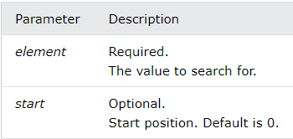
* const fruits = ["Banana", "Orange", "Apple", "Mango"];  
  fruits.includes("Mango");
* The above returns true
* const fruits = ["Banana", "Orange", "Apple", "Mango"];  
  fruits.includes("Banana", 3);
* The above returns false since we start searching from position 3

from()

* Array.from() lets you create Arrays from: array-like objects (objects with a length property and indexed elements); or iterable objects (objects such as Map and Set)
* Array.from('foo') returns the value [“f”, “o”, “o”]
* 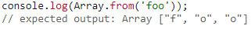
* Syntax: Array.from(object, mapFunction, thisValue)
* Array.from() has an optional parameter mapFn, which allows you to execute a map() function on each element of the array being created. More clearly, Array.from(obj, mapFn, thisArg) has the same result as Array.from(obj).map(mapFn, thisArg), except that it does not create an intermediate array, and mapFn only receives two arguments (element, index).

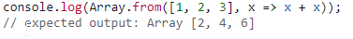

forEach()

* forEach() method calls a function for each element in an array. (equivalent to a ‘for x in my_list’ in python)
* The forEach() method is not executed for empty elements.
* *Syntax: array*.forEach(function(currentValue, index, arr), thisValue)
* 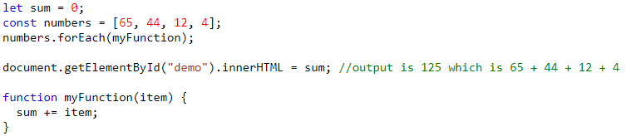
* 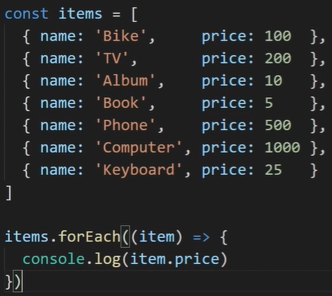

**Objects**

Object Definition

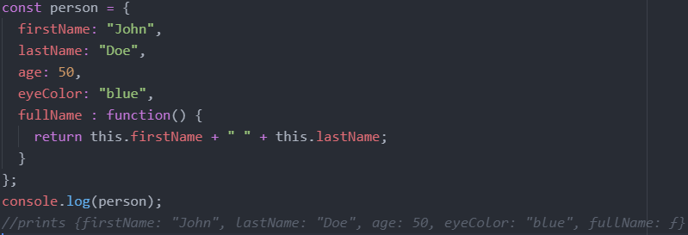

This Keyword

In a function definition, this refers to the "owner" of the function.

In the example above, this is the person object that "owns" the fullName function.

In other words, this.firstName means the firstName property of this object.

Accessing Object Properties

let name1 = objectName.propertyName

let name2 = objectName["propertyName"]

Accessing Object Methods

let fullname = objectName.methodName()

Property Shorthand

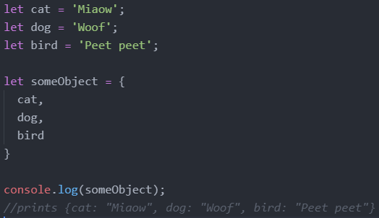

Destructuring

* The destructuring assignment syntax is a JavaScript expression that makes it possible to unpack values from arrays using square brackets, or properties from objects using curly brackets, into distinct variables.
* We take the array we want to destructor and we put it on the right side of the expression. Below we put the alphabet array on the right. Then we declare variables a inside brackets to take on the value of the first element of alphabet.
* 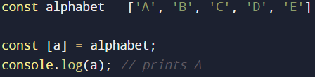
* We can also take more than just one element from the array. The position of the elements corresponds to the position of the variable declared. Below, since a is the first item and b is the second item in [a,b], a takes on the first element in alphabet and b takes on the second element in alphabet.
* 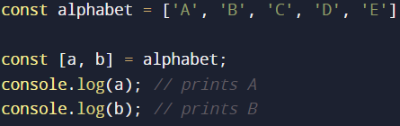
* 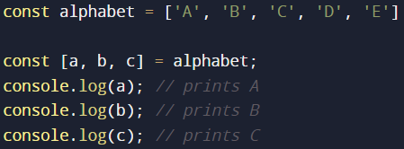
* Suppose we only wanted a and c, then we could remove the variable declaration for b, but leave in the commas.
* 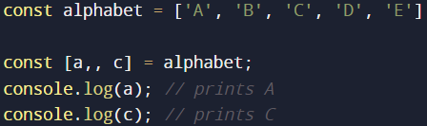
* Destructuring is useful when it comes to getting return values from functions.
* 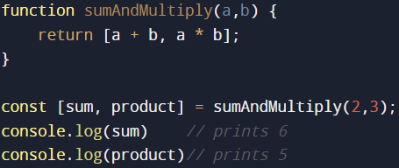

Destructuring with objects

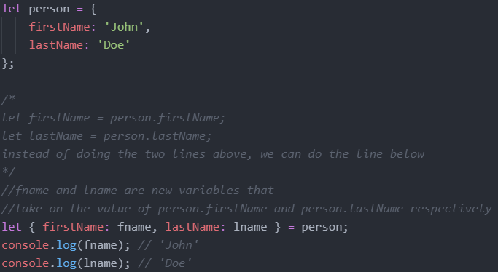

Declaring variables that have the same names as the properties of the object

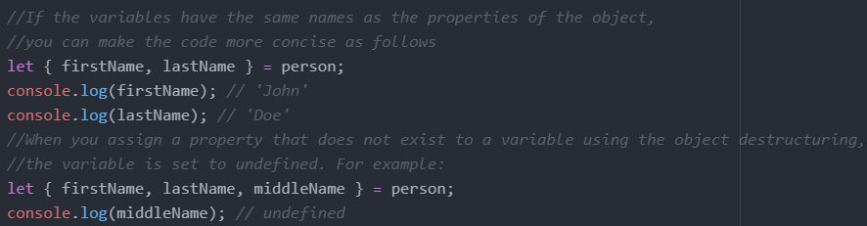

Default values

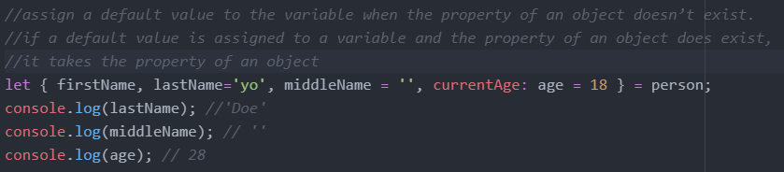

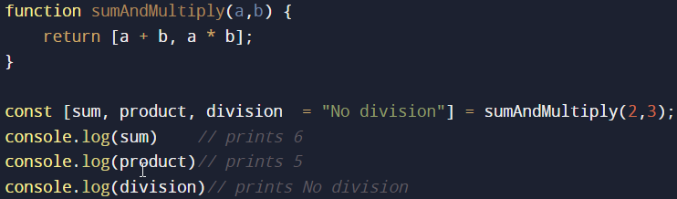

Nested object destructuring

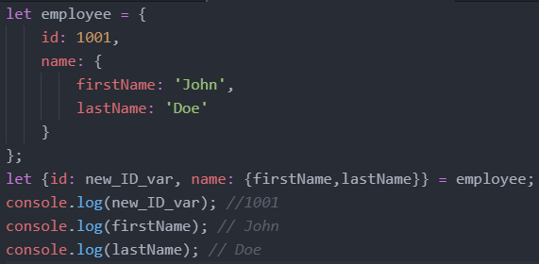

* We can also use object destructuring inside the arguments of functions
* 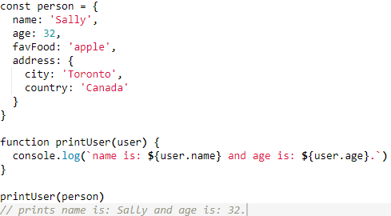
* Instead of the above, we could write the following
* 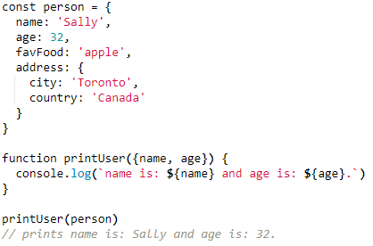

Spread Operator

* We will continue from the example with the destructuring operator
* We know how to get the 1st and 3rd elements of an array without needing to get the 2nd element as shown below.
* 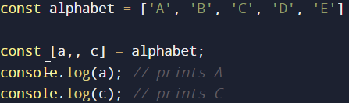
* But what if we want to get the rest of the array elements? We can use the spread operator
* 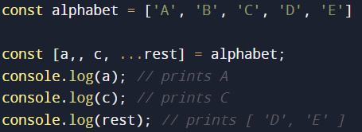
* rest is not a keyword, we get to choose the name
* we can use the spread operator to combine two arrays together as shown below
* 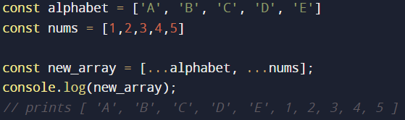
* The above is not too useful since we could use concat() instead, but it becomes useful for objects as shown below.
* We can copy an array (with different memory address) by using:
* Const new_array = […old_array]
* 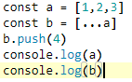=> 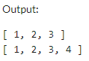
* Spread with objects
* Notice below the name property is not in the variable rest since we already took it out
* 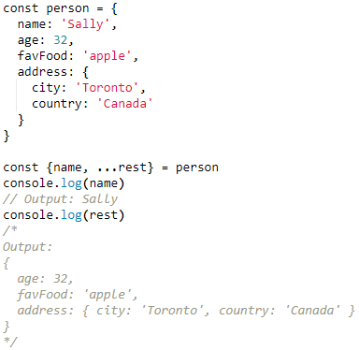
* 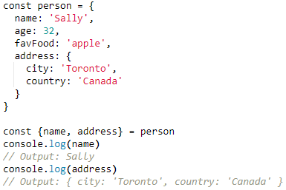
* We can also destructure nested objects
* 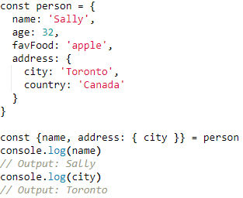
* We can also combine objects
* 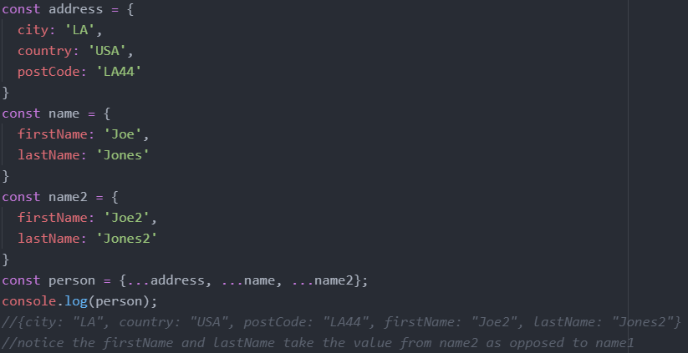
* We can copy an obj (with different memory address) by using:
* const new_obj= {...old_obj}
* 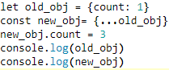=> 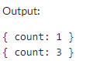

**Objects vs Arrays**

Arrays use numbered indexes while objects used name indexes

**Null vs Undefined**

* Similarities:
  + null and undefined both mean there is no value for a given thing we are trying to access
  + null == undefined // this is true
  + We can do let a = null and we can also do let a = undefined. However, let a; initializes a as undefined so the only time we would use let a = undefined is if we want to reset the variable a.
* Differences:
  + The only real difference between the two is the actual intent the programmer is trying to show.
  + It is not possible to get the keyword null in JavaScript unless some programmer specifically returns the keyword null. Thus, by using null, the programmer is explicitly saying that this thing has no value (I checked for the value, did some calculations, but there is no value). A good is example is that if we are checking if something is in a list. If it’s not in the list, we can return null.
  + Undefined is not saying that the thing has no value. It is just saying that the thing has not been defined yet. So if you do let a; and not define it, a has a value of undefined. So undefined is the default state of everything (everything is undefined until you define it).
  + Thus by using null we are saying the thing has been defined, but it has no value. By using undefined, we are saying this thing is not yet defined (it could have a value later or not have a value later, we don’t know, but as of now, the value just doesn’t exist yet).
  + null === undefined // this is false
* TLDR: null means the thing exists, it just has no value. Undefined means the thing doesn’t exist yet.

**String Methods**

Length

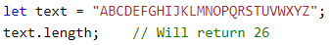

Escape Characters

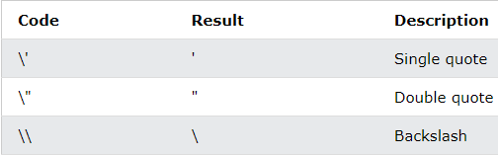

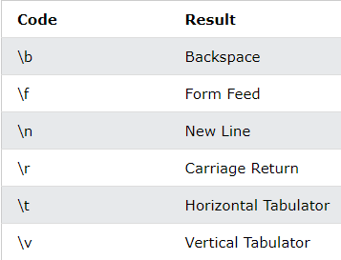

Literals Vs Objects

Normally, JavaScript strings are primitive values, created from literals, but strings can also be defined as objects with the keyword new.

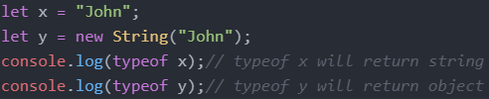

Comparing Strings and Objects/Strings

The == operator returns true if the values of two strings or objects are equal

The === operator returns true if the values and data types are equal

1 ==1 is true and 1===1 is true

1 == ‘1’ is true since the string ‘1’ is converted to an int which is 1 and they are equal. but 1 === ‘1’ is not true since an integer and string are not of the same type.

Below is a list of weird shit. You just need to know they exist, not why that’s the case.

* + 0 == ‘’ is true
  + 0 === ’’ is false
  + 0 == false is true
  + 0 === false is false
* A good use case of the === is to differentiate between null and undefined
  + null == undefined is true
  + null === undefined is false
* In general, always use === instead of == unless we are comparing null vs undefined.

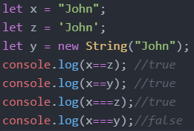

Comparing Objects and Objects

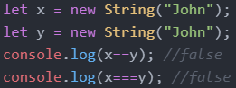

Slice()

extracts a part of a string and returns the extracted part in a new string

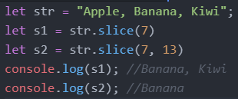

* We can copy an array (with different memory address) by using:
* Const new_array = old_array.slice()
* 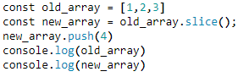=> 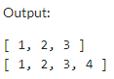

Replace()

The replace() method replaces a the first instance of a specified value with another value in a string

The replace() method is case sensitive

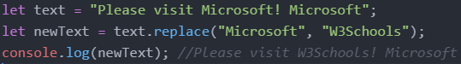

To replace case insensitive, use a regular expression with an /i flag (insensitive)

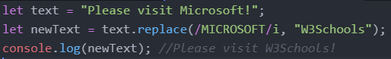

To replace all matches, use a regular expression with a /g flag (global match)

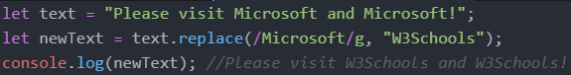

charAt()

The charAt() method returns the character at a specified index (position) in a string

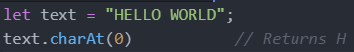

indexOf()

The indexOf() method returns the index of (the position of) the first occurrence of a specified text in a string, or -1 if not found

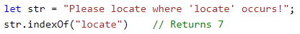

lastIndexOf()

The lastIndexOf() method returns the index of the last occurrence of a specified text in a string:

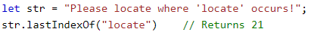

Convert String to Array

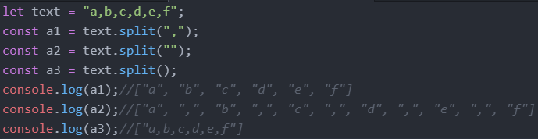

**Sets**

**Random**

Math.random() returns a random number between 0 (inclusive) and 1 (exclusive)

Ex: Return a random integer between 1 and 10: Math.floor((Math.random() * 10) + 1);

**Immutable Vs Mutable Data Types**

Immutable: Numbers, Strings, Null, Undefined, Booleans

In the example below, when we do let b = a, b takes on the value of a, not the memory address of a. As well the 10 which is the value of a and the 10 which is the value of b are two different 10s as they are stored in different memory addresses.

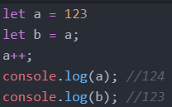

Mutable: Arrays, Objects, Functions, Classes, Maps, Sets

In the example below, when we do let b = a, b takes on the memory address of a.

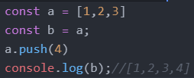

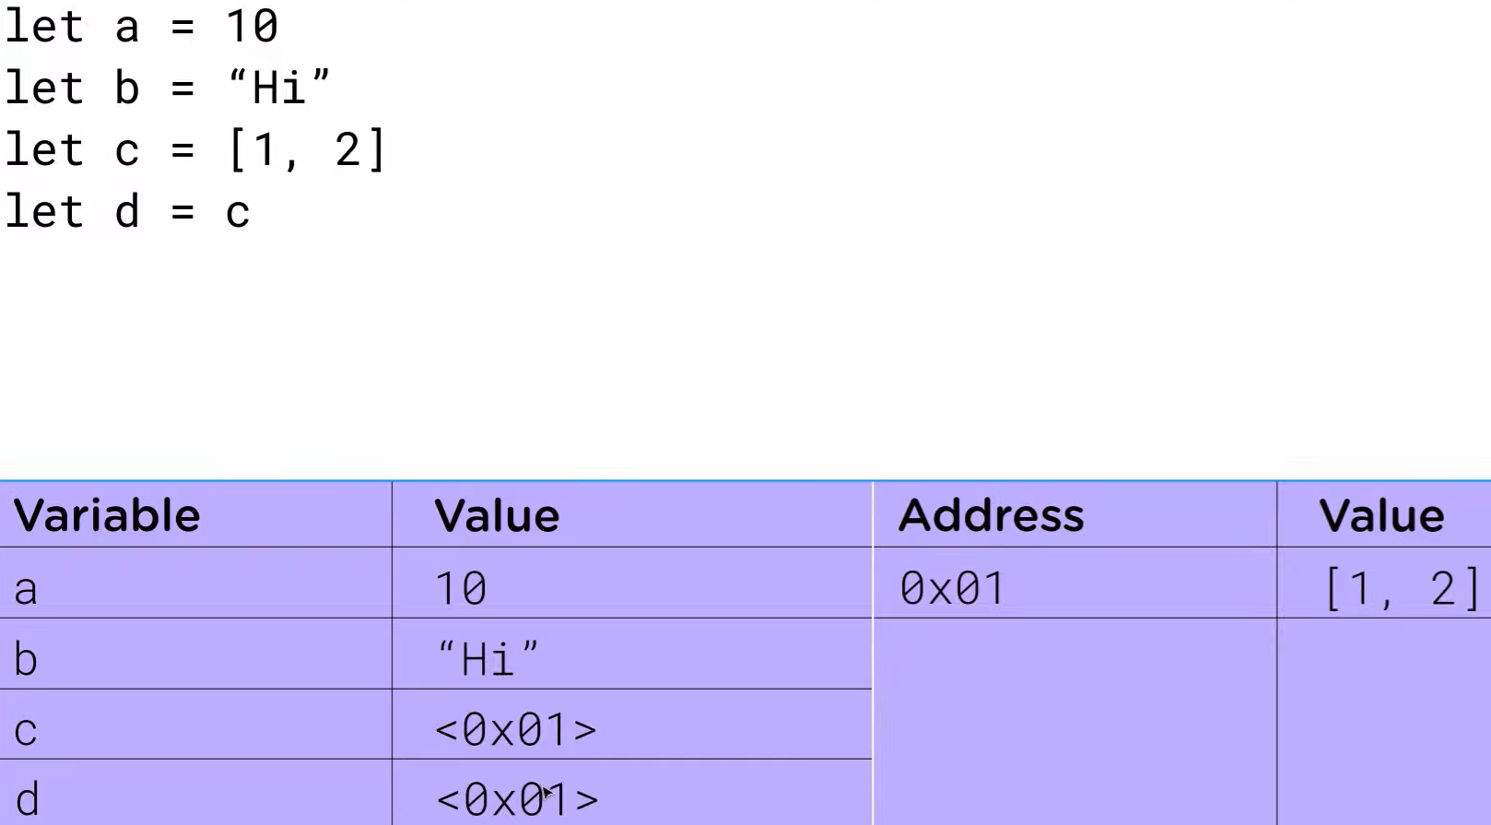

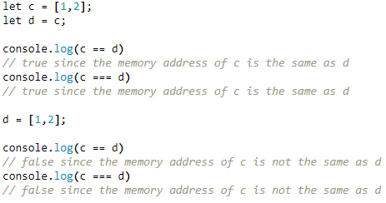

**If Statements**

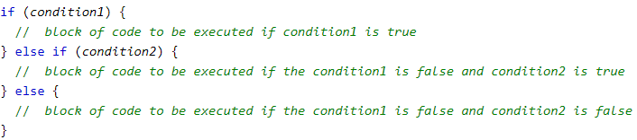

Logical Operators in Javascript such as && or || evaluate from left to right and they short circuit. Short circuiting means that in JavaScript when we are evaluating an AND expression (&&), if the first operand is false, JavaScript will short-circuit and not even look at the second operand. The same applies for OR if the first operand is true. Through short circuiting, the following two blocks of code are the same.

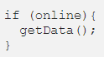 

In the left block of code, if online is true, getData is run. If online is false, getData isn’t even looked at. In the right block of code, it reads from left to right so it first checks if online is true. If online is false, it short circuits and doesn’t even read the getData(). If online is true, it runs getData(). Note that getData() is any function and doesn’t have to return a boolean.

Thus, code such as isLoaded && renderContent() is very common in react when it comes to rendering content conditionally without having to use an if statement.

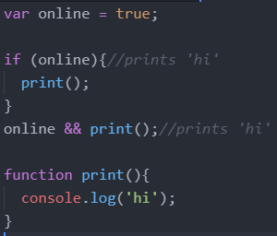

**Ternary Operator**

The syntax for a ternary operator is condition ? expr_if_cond_is_true : expr_if_cond_is_false

This ternary operator should only be used for basic if statements, don’t overdo it.

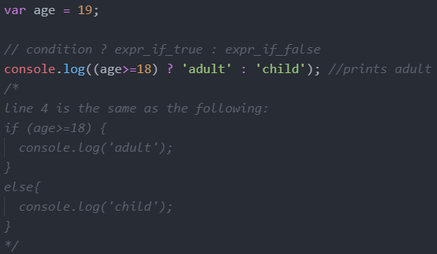

Multiple Operations Per Condition

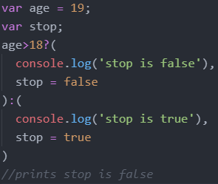

Nested Ternary Operations

Don’t use nested ternary operators, it just makes it more difficult to read

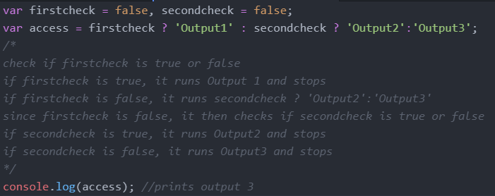

The following two conditions (one with if, one with ternary) are equivalent

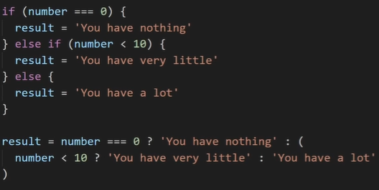

Try Catch Finally

* the try statement defines a code block to run (to try).
* The catch statement defines a code block to handle any error.
* The finally statement defines a code block to run regardless of the result.
* The throw statement defines a custom error.
* 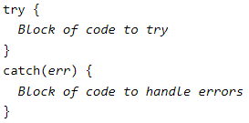
* Ex:
* 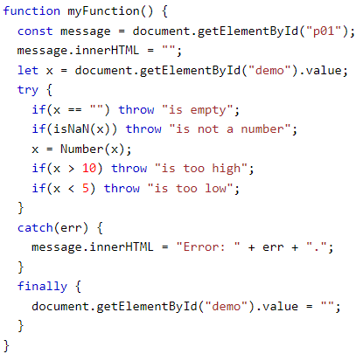

**Loops**

For Loops

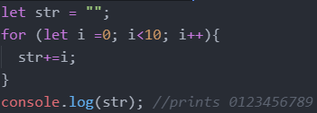

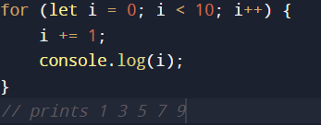

While Loops

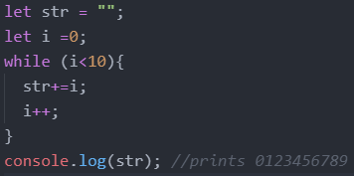

Break and Continue

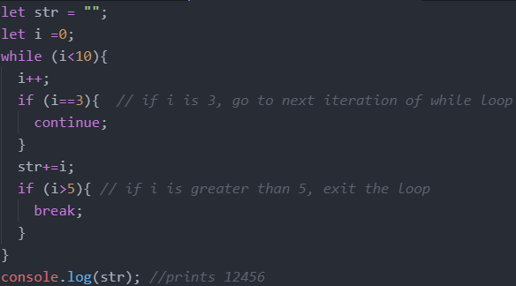

**Function**

Declaration

The function declaration (function statement) defines a function with the specified parameters.

Function declarations in JavaScript are hoisted to the top of the enclosing function or global scope. You can use the function before you declared it. You can also declare the function then use it.

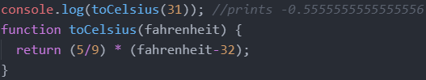

Functions are pass by value, Function arguments are local variables in JavaScript.

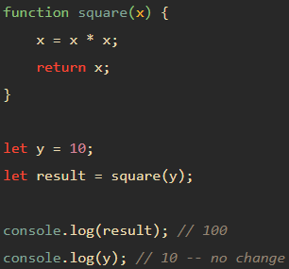

Reference values are also passed by values. The value passed in is the memory address.

Consider the code below:

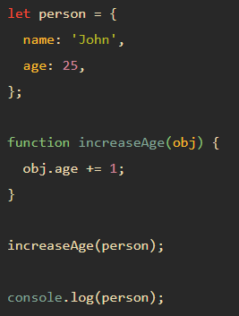

The console will output the person object with an age of 26. But if the parameter is pass by value, how is it able to change the person object?

First, define the person variable that references an object with two properties name and age.

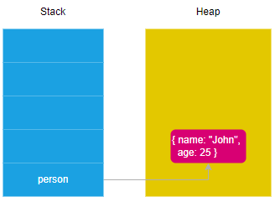

Next, define the increaseAge() function that accepts an object obj and increases the age property of the obj argument by one.

Then, pass the person object to the increaseAge() function:

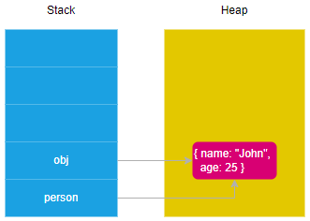

Internally, the JavaScript engine creates the obj variable that points to the same memory address as the object. After that, increase the age property of the obj variable by one inside the increaseAge(). But since obj and person point to the same memory address, changing obj also changes person.

It seems that JavaScript passes an object by reference because the change to the object is reflected outside the function. However, this is not the case. In fact, when passing an object to a function, you are passing the memory address of that object, not the actual object. Therefore, the function can modify the properties of the object via its memory address.

However, you cannot change the memory address of the object that is passed as a parameter.

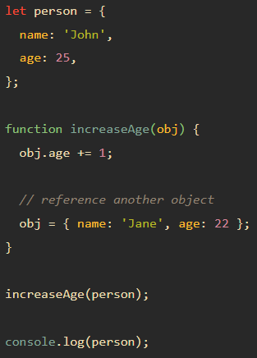

The code is the same as above. The obj variable points to the same location in memory as the person object. But the second we say obj = { name: ‘Jane’, age: 22 }, the obj variable points to a new location in memory, thus not changing any properties of the person object.

Expression/Anonymous

A function expression can be stored in a variable

Definition

The function keyword can be used to define a function inside an expression.

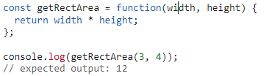

Hoisting

Function expressions in JavaScript are not hoisted, unlike function declarations. You can't use function expressions before you create them.

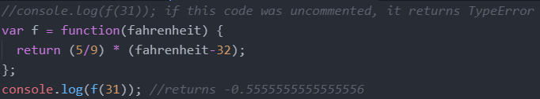

Named Function Expression

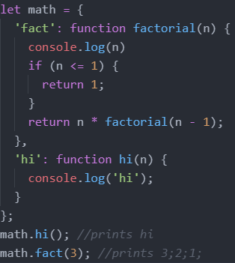

Arrow Functions

Arrow functions allow us to write shorter function syntax

Below shows how the code gets shorter and shorter and closer and closer to arrow function notation using the functions hi1, hi2, hi3, hi4.

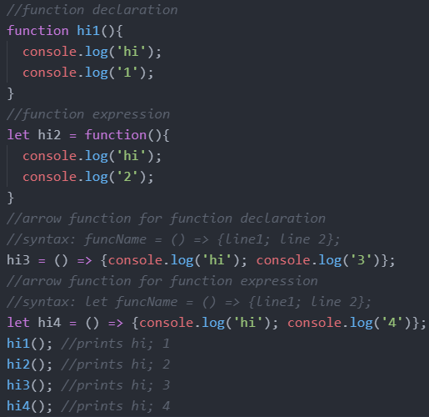

The following functions are the same, aside from their name

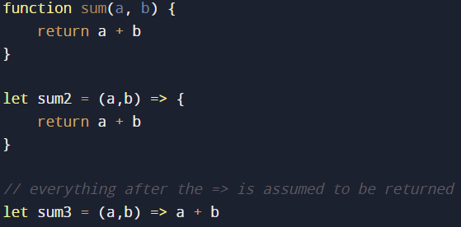

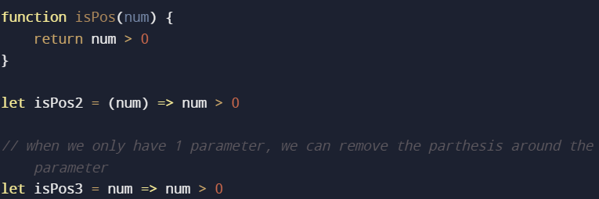

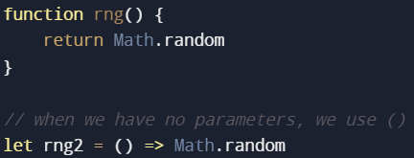

Arrow functions don’t really decrease the amount of code you have to write, but it can be very useful when you need to create an anonymous function that doesn’t have any descriptive function name.

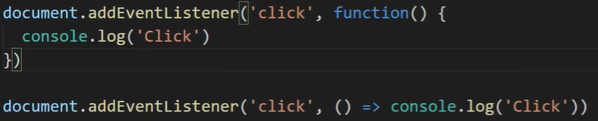

In the example above, the second eventlistener uses an arrow function while the first doesn’t.

However, there is one more difference between arrow functions and normal functions

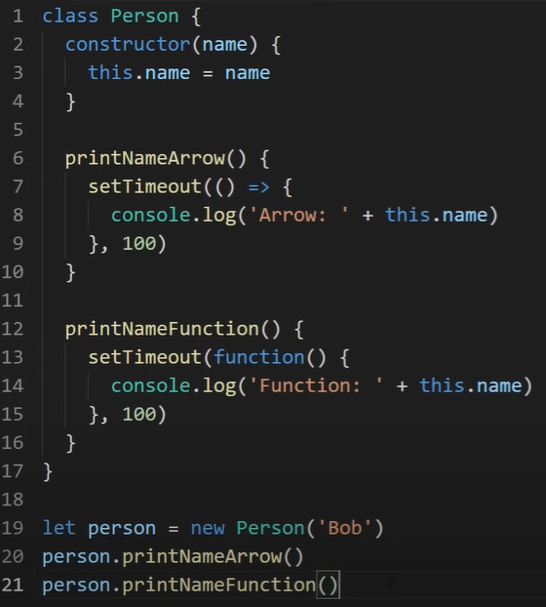

When we do person.printNameArrow() on line 20, it prints “Arrow: Bob”

When we do person.printNameFunction() on line 21, it prints “Function: ”.

The “this keyword” is different inside a normal function and an arrow function. Normal functions define the “this keyword” depending on where the function was called. Since the printNameFunction was called on line 21, this.name for the printNameFunction would have the same scope as where the printNameFunction was called. In this case, this.name for the printNameFunction has global scope. But this.name has not been defined in the global scope which is why nothing is being printed. Notice if we did console.log(this.name), it would print nothing because this.name is not defined in the global scope.

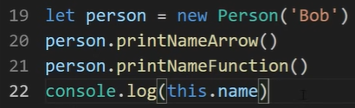

On the other hand, the “this keyword” has the same scope as inside the printNameArrow function. The this.name for the printNameArrow does not redefined when we use an arrow function. Thus, this.name for the printNameArrow does not have global scope, but rather the same scope as inside the printNameArrow function and this.name has been defined in the printNameArrow function scope (in line 3) which is why it prints “Bob”.

Because of this, we generally use arrow functions since the effect that normal functions have on the “this” keyword is really confusing.

Closures

* when you have a function defined inside of another function, that inner function has access to the variables and scope of the outer function even if the outer function finishes executing and those variables are no longer accessible outside of that function
* 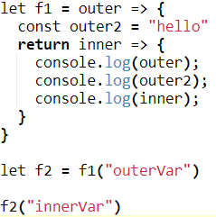=>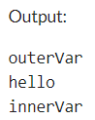
* If after we said f2(“innerVar”) we had the line console.log(outer), we would get an error since outer is no longer defined. However, f2 still able to access the variable outer which in our example has a value of “outerVar”. Notice f2 knows what the value of outer2 even though it was defined outside the scope of the inner function (aka the return value of f1).
* If a function references refences data outside of its own scope (such as like the global environment or outer function), it stores the data in heap memory. This is different from the call stack which is short lived since once a function is removed from the call stack, so are all the variables inside that function. But since we are storing the value of the data the inner function refences in the heap, the data is not lost. Thus, closures use more memory and computation, but we get more data encapsulation.
* <https://www.youtube.com/watch?v=vKJpN5FAeF4>
* Ex: what does the following print
  + 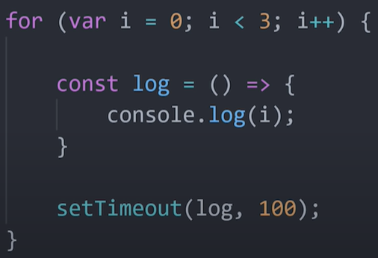
  + Output: 3, 3, 3
  + When we say var i = 0; i is hoisted to the scope of the parent and exists outside the for loop, which in this case is global scope. We have one global variable that we are mutating over and over. Thus, i is stored in heap memory so it can be referenced again when that closure is called by the setTimeout function. Before we log out i, we would have already finished looping so that means we would have already updated the value of i to be 3. Then, the setTimeout function runs the log function 3 times, each printing i which has a value of 3.
  + Note that it doesn’t matter if the timeout is 0 seconds since it is pushed into the macroevent queue which means it gets executed after the for loop is finished.
  + If we were to say let i = 0; we would get an output of: 1, 2, 3. With let, we are creating a variable that is scoped to the block (in this case the for loop). Thus i is local to the for loop and cannot be accessed outside of it. i would exist on the call stack, but would get immediately removed once the for loop is pushed off the call stack. Thus, we have many different i's, each specific to their associated stack frame. When we create the function log, the i it references is the i so far in the for loop (since the only way to reference i is the stack frame. If we try to refence i later, the stack frame would have already been pushed off the call stack so i would not be accessible). When the setTimeout functions runs the log function 3 times, each prints the value of i of the time of the log function creation.

Recursion

* 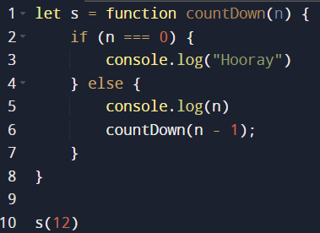 will print 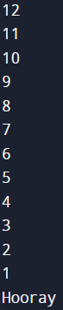

**Template Literals**

Template Literals use back-ticks (``) rather than the quotes ("") to define a string.

With template literals, you can use both single and double quotes inside a string, multiline strings, and interpolate variables and expressions into strings. In order to add a variable inside a template literal the variable must be wrapped inside curly braces that start with a dollar sign ${}.

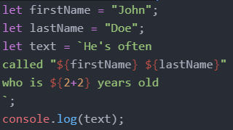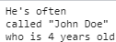

Template literals also give you the ability to define a string on multiple lines and keep all of the whitespace when printed.

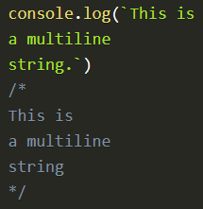

One thing to watch out for with this approach, though, is that even the extra whitespace used at the beginning of lines is included in the output. This can lead to some confusing bugs with the output if you are not careful.

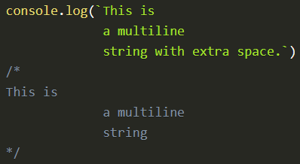

Tagged Template Literals

* Tagged template literals are simply the ability to run a function on the content of a template literal.
* An example of an already existing tagged template literal is the String.raw function. This tagged template literal will make it so that all escape sequences such as new lines are not computed and instead just printed as plain text.
* 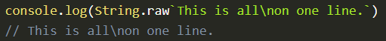
* Immediately, looking at this code looks weird. There are no parenthesis around the argument to String.raw, but that is how tagged template literals work. A tagged template literal is called by putting the name of the function and then immediately following it with a template literal string.
* We can also pass in our own functions to be applied on a template literal.
* 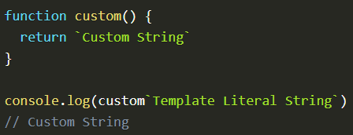
* The first parameter to the function is an array of all the strings in the template literal separated by the ${} expressions.
* 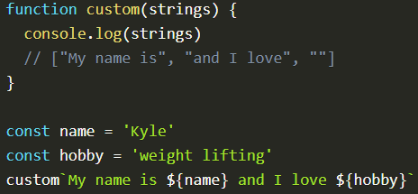
* The rest of the parameters to the function correspond with each of the ${} expressions in the order they appear in the template. This means if there are four ${} expressions in the string then there will be four extra variables passed to the function, one for each variable.
* 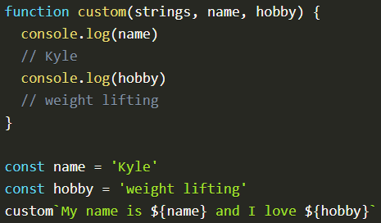
* Many times you will not know how many ${} expressions a string will have, so you can use the rest operator to group all the ${} expressions into one array.
* 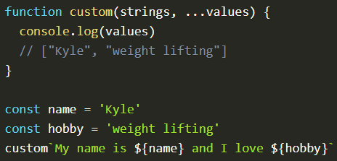
* With this syntax we now have all the information we need to reconstruct the string passed into the tagged template literal.
* 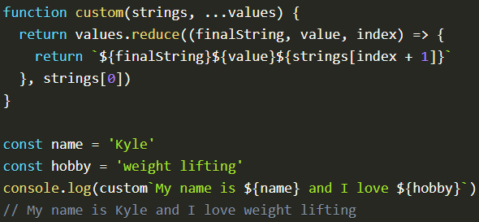
* Recall strings is an array of all the all the strings in the template literal separated by the ${} expressions. (does not include the stuff inside the ${} expressions)
* Recall …values is a array of the stuff inside ${} expressions.
* Recall that reduce’s first parameter is the function that will be applied to all the elements of a given array. The second parameter is the initial value. The function (first parameter of reduce) says that it will add the next thing inside the ${} expressions followed by the next string seperated by the ${} expressions all onto the end of the previous result.
* The output is as follows:
* My name is
* My name is Kyle and I love
* My name is Kyle and I love weight lifting.
* One thing we could do is bold all values from ${} expressions since we have access to each value inside the values array.
* 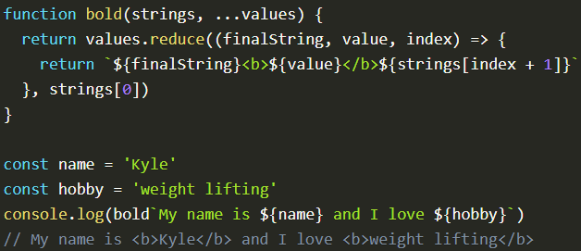
* Removing Newlines From Multiline Strings
* 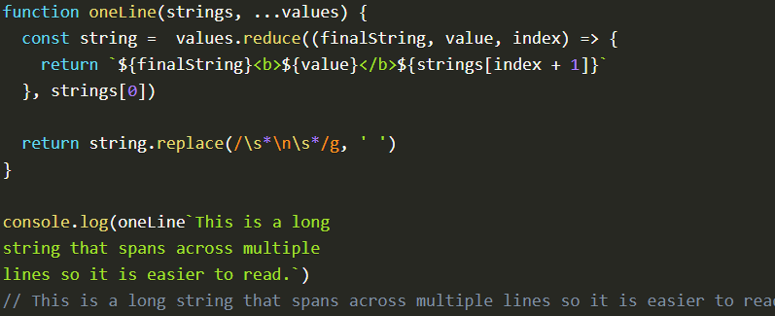

**Error Handling**

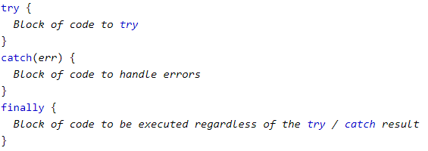

Ex:

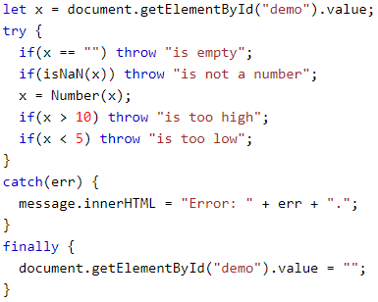

**DOM (Document Object Model)**

* The Document Object Model (DOM) is an application programming interface (API) for manipulating HTML documents.
* The DOM represents an HTML document as a tree of nodes. The DOM provides functions that allow you to add, remove, and modify parts of the document effectively.
* The DOM is not part of the JavaScript language, but is instead a Web API used to build websites.
* The DOM represents an HTML document as a hierarchy of nodes.
* Consider the following HTML document:
* 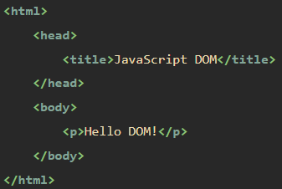
* The following tree represents the above HTML document:
* 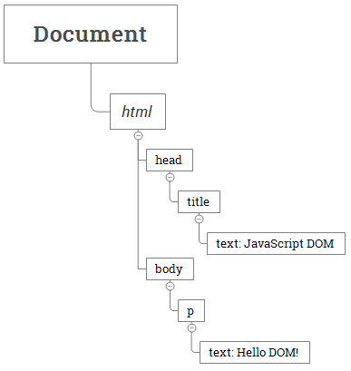
* An example of another tree could be the following:
* 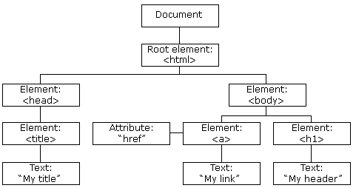
* In this DOM tree, the document is the root node. The root node has one child node which is the <html> element.
* The <html> element is called the document element. Each document can have only one document element. In an HTML document, the document element is the <html> element.

Node Types

* Each node in the DOM tree is identified by a node type. JavaScript uses integer numbers to determine the node types. The following table illustrates the node type constants:
* 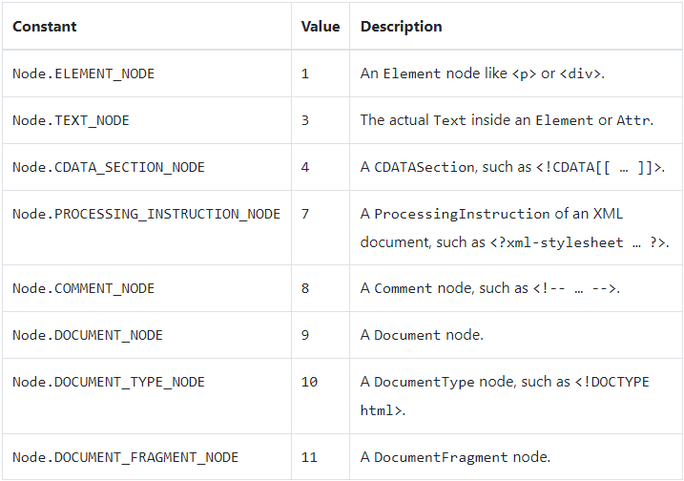
* To get the type of a node, you use the nodeType property: 
* You can compare the nodeType property with the above constants to determine the node type. For example:
* 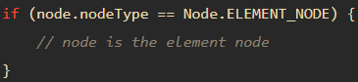

The nodeName and nodeValue properties

* A node has two important properties: nodeName and nodeValue that provide specific information about the node.
* The values of these properties depend on the node type. For example, if the node type is the element node, the nodeName is always the same as the element’s tag name and nodeValue is always null.
* For this reason, it’s better to test node type before using these properties:
* 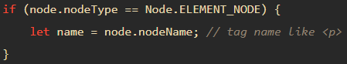

Node vs Element

* A node is anything within an HTML documents including comments, text, HTML elements, and more.
* An element is specific type of node with a node type Node.ELEMENT_NODE, which is equal to 1. Elements are only HTML elements such as <span>, <div>, <body>, <a>, etc.
* Since an element is a specific type of node, all the methods/properties that apply to nodes apply to elements as well. But an element has some additional specific properties that nodes in general don’t have.
* Oftentimes, we use element instead of nodes because we don’t really care about comments or text.
* The following picture illustrates the relationship between the Node and Element types:
* 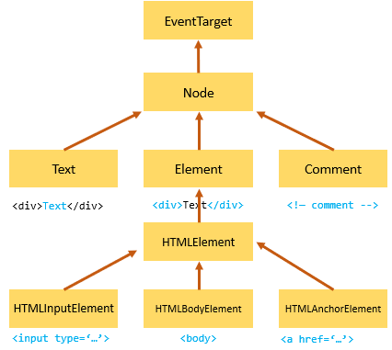
* Consider the HTML below:
* 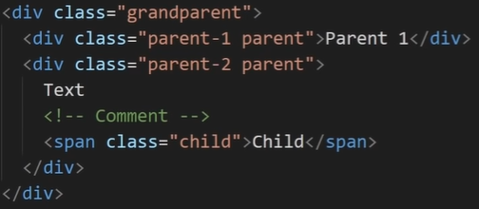
* If we did the following, parent1 would be the div with the class name of “parent-1”. Parent1.parentElement gets the parent element of parent1 which is the div with the class name of “grandparents”.
* 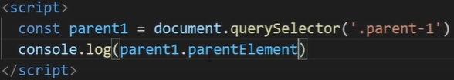
* However, if did the following, we would get the exact same thing.
* 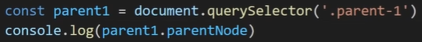
* They are the same since the div with class name of “grandparent” is both an element and a node.
* However, lets consider the following code. We would log out an empty HTML collection.
* 
* If we used childNodes instead as shown below, we would get the following:
* 
* 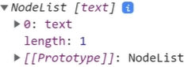
* Notice we don’t log out an empty HTML collection but a NodeList that contains some text. This is because childNodes returns all the nodes of a given element. Text is a node, but not an element which is why childNodes contains the text but children doesn’t.
* All HTML methods has two versions, one for getting the elements and one for getting the nodes.

HTML Collection vs NodeList

* An NodeList contains nodes while an HTML collection only contains elements.
* Only the forEach array method can be used on NodeList. However, no array methods can be used on HTML collections.
* Live Updates
  + A live update is when a new element is added to the page and it would match the elements in the list, it is automatically added to the list.
  + An html collection always live updates
  + A node list sometimes live updates
  + Consider the code below:
  + 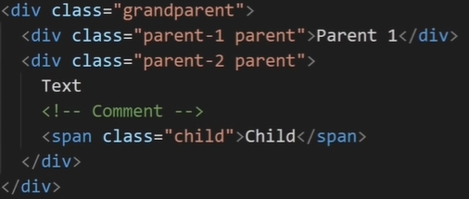
  + The below code is essentially adding a new parent div to the grandparent div. Let’ say we use getElementsByClassName which returns an HTML collections.
  + 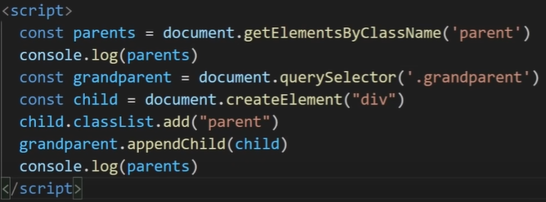
  + The output would be the following:
  + 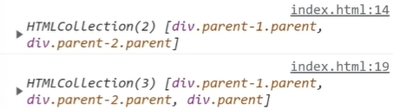
  + Notice that the outputs are different as the new parent div we added to parents was displayed. This is because we said parents = document.getElementsByClassName which returns an HTML collection which automatically live updates itself.
  + Now consider the code below where we use querySelectorAll instead of getElementsByClassName.
  + 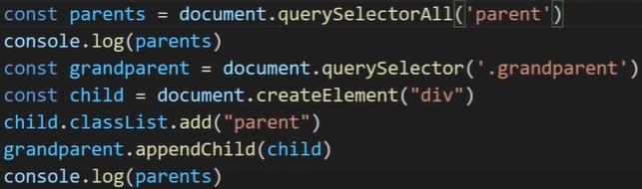
  + The output would be the following:
  + 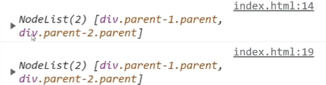
  + Notice that the outputs are the same even though we created a new parent div and added it to parents. This is because we used querySelectorAll which returns a NodeList which does not have live update.

Node Relationships

* Any node has relationships to other nodes in the DOM tree. The relationships are the same as the ones described in a traditional family tree.
* For example, <body> is a child node of the <html> node, and <html> is the parent of the <body> node.
* The <body> node is the sibling of the <head> node because they share the same immediate parent, which is the <html> element.
* The following picture illustrates the relationships between nodes:
* 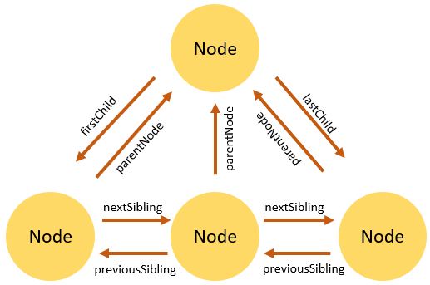

DOM Traversal

|  |
| --- |
| **Finding HTML Elements** |
| **Method** |
| document.getElementById(“id_name”) (return is Element type) |
| document.getElementsByTagName(“p”) (return is NodeList) |
| document.getElementsByClassName(“class_name”) |
| document.querySelector(“.className”) (This only gives us one element despite many elements possibly having the class name of className. This returns the first element with the class name of className) (returtn is Element Type) |
| document.querySelectorAll(“.className”) (this gives us all of the elements with the class name of className). (return is NodeList) |
| document.querySelector(“#idName”) |

Consider the HTML below:

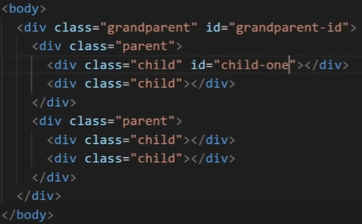

Selecting Children

Suppose we are given a DOM element and we want to get all the elements right underneath it. (not to the side of it or above, but right below), we can use .children.



The .children will give us all the children of a given element. In this case, the children would be the two divs with class of parent. The datatype of parents is an HTMLCollection which is a live, ordered collection of the DOM elements which are children of grandparent. You can access the individual child nodes in the collection by using either the item() method on the collection, or by using JavaScript array-style notation. If the element has no element children, then children is an empty list with a length of 0.

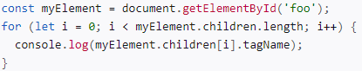

To make it easier for us to use the collection of children elements, we couldve said the following instead which makes it an array



Thus, parents[0] would give us the Element object that represents the first element in parents.

Selecting Descendants

Suppose we are given a DOM element and we want to find a certain element below it (not to the side of it or above it, but below), we can use .querySelector



Notice we are apply the querySelectorAll on a single element object. This is no different that what we were doing before since before, we applied querySelector on document which is the root node. Grandparent is now just some other node so we can also apply querySelector on it no differently.

In the above example, we are looking for the all the elements that have a class of “child” that are also descendants of the Element object stored in the grandparent variable.

Selecting Parents

Suppose we are given a DOM element and we want to find the element right above it (not to the side of it or below it, but right above), we can use .parentElement. We could also use .parentNode but that might sometimes select a node which is not what we want.

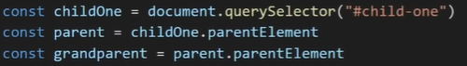

Selecting Ancestors

Suppose we are given a DOM element and we want to find a certain element above it (not to the side of it or below it, but above), we can use .closest which works the same as querySelector but closest goes upwards while querySelector goes down the tree.

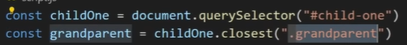

When we do childOne.closest(“.grandparent”), we will go to childOne’s parent to get an element with class “parent”. Since “parent” is not “grandparent”, we go look at “parent”’s parent which does have a class of “grandparent”.

Selecting Siblings

Suppose we are given a DOM element and we want to find the element right after it with the same hierarchy. We can use .nextElementSibling. We can use previousElementSibling to get the previous element with the same hierarchy.





childTwo is highlighted below in black.





 this returns the element highlighted in red.



DOM Manipulation

* HTML DOM properties are values (of HTML Elements) that you can set or change.
* HTML DOM methods are actions you can perform (on HTML Elements)
* When we target an element using one of the selectors below, we get an Element object that represents the element.

Adding Elements

* + We can use append which allows us to append nodes.
  + 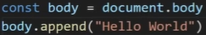
  + 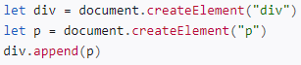
  + We can also append many nodes
  + 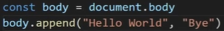
  + We can use appendChild which only allows us to append elements. We can also appendChild 1 element at a time.
  + 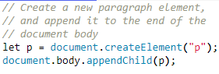

Creating Elements

* + We can use createElement as shown below.
  + 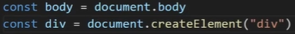
  + Note that creating the element does not add the element so we also have to add it as shown below.
  + 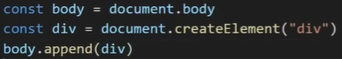

Modifying Text in between Element Tags

* + We can user innerText or textContent
  + innerText
    - 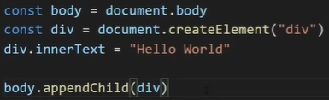
    - Output:
    - 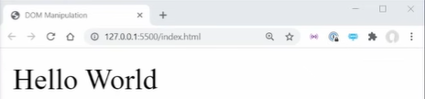
  + textContent
    - 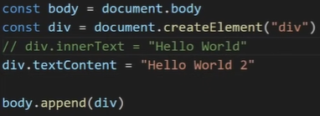
    - Output:
    - 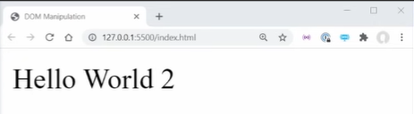
  + When it comes to setting the text inside HTML elements, innerText and textContent are the same. However, when we view them, they are different.
  + Consider the HTML below:
  + 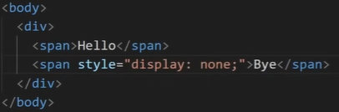
  + Then consider the following JS Code:
  + 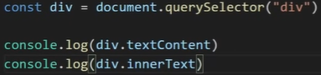
  + The output is the following:
  + 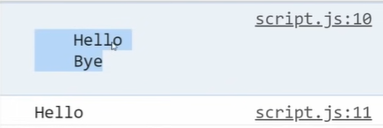
  + Notice that textContent includes spacing while innerText doesn’t. Also notice that textContent displays ‘Bye’ but innerText doesn’t since innerText only prints out the visible text.

Modifying Elements in between Element Tags

* + We use innerHTML
  + 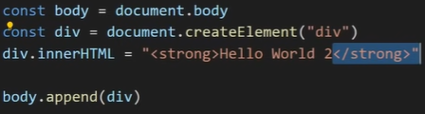
  + Output:
  + 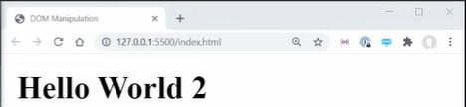
  + Notice the <strong> element we added did not output as text, but rather was turned into an HTML element which is why the text “Hello World 2” is bolded.
  + However, if we are getting the text for the innerHTML from the user, it is possible the user inputs some malicious stuff so innerHTML is not that secure.
  + What is more secure is the following using innerText which does the same as the above, but in a more secure way:
  + 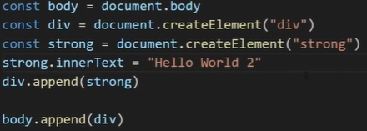

Removing Elements

* + 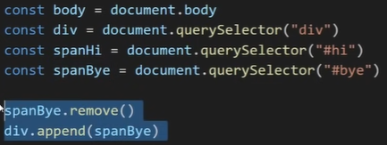
  + Notice we remove an element by using .remove() which completely removes it from the HTML. But we can still access it in the JS as shown in the following line where spanBye is added back.

Getting Element Attributes

* + We can get attributes such as id’s and title’s of an element using getAttribute as shown below
  + 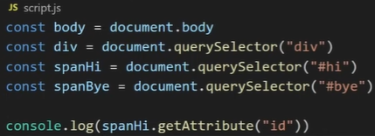
  + However, attributes are oftentimes already methods of an element so we can just do the following instead:
  + 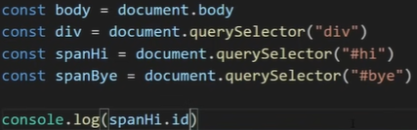

Setting Element Attributes

* + Below we change the id to sdfsdfsd
  + 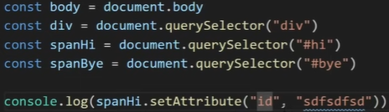
  + Or we can also do the following
  + 

Removing Element Attributes

* + By using removeAttribute as shown below, we remove the id attribute of spanHi so spanHi no longer has an id at all.
  + 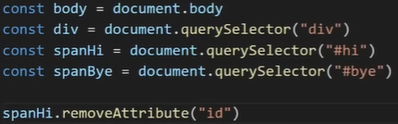

Modifying Element Classes

* + We can use classList to allows us to use many methods is manipulating the class of an element.
  + Adding a class to an element
    - 
  + Removing a class from an element:
    - 
  + Toggle a class from an element
    - (removes the class if the element already has it, or adds the class if to the element if the element doesn’t have it).
    - 
    - We could also pass in a boolean parameter which adds it if we say true and removes it if we say false
    - 

Modifying CSS

* + We can use style to allows us to use many methods is manipulating the style of an element.
  + 
  + 
  + Notice above we have to convert background-color which is what we would write in CSS to backgroundColor using camelCase.

|  |
| --- |
| **Adding Events Handlers** |
| **Method** |
| document.getElementById(id).onclick = function(){code}  Examples:  document.getElementById("myBtn").onclick = displayDate; |

Events

onclick

onmousedown

onmouseup

onload

onunload

onchange

onmouseover

onmouseout

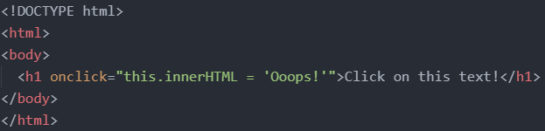

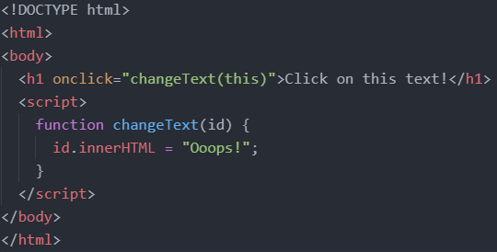

Event Listener

Syntax: element.addEventListener(event, function, useCapture);

- The first parameter is the type of the event (like "click" or "mousedown" or any other HTML DOM Event.). Note that you don't use the "on" prefix for the event; use "click" instead of "onclick".

- The second parameter is the function we want to call when the event occurs.

- The third parameter is a boolean value specifying whether to use event bubbling or event capturing. This parameter is optional.

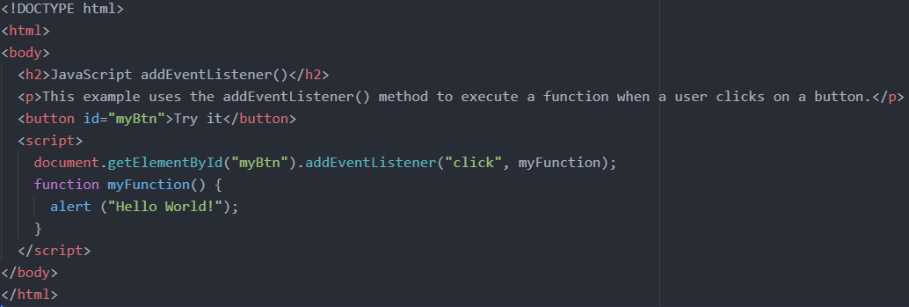

Forms

Get the value of an input field through document.getElementById("input_field_id").value;

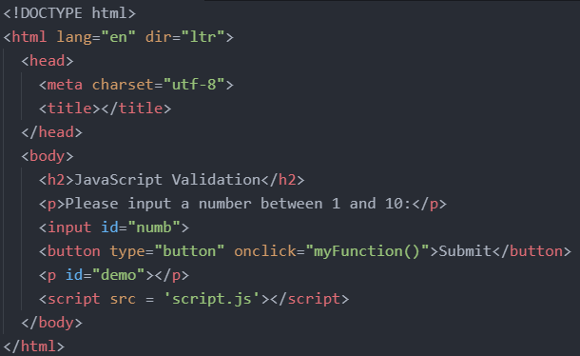

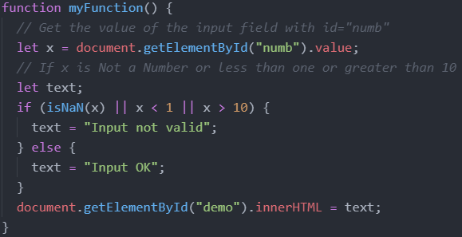

**Classes**

A JavaScript class is not an object. It is a template for JavaScript objects. An object is an specific instantiated version of a class with all the property values filled in.

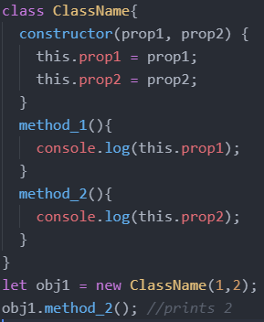

It has to have the exact name "constructor". The constructor method is called automatically when a new object is created. If you do not define a constructor method, JavaScript will add an empty constructor method.

Inheritance

To create a class inheritance, use the extends keyword.

A class created with a class inherits and inherits all the methods from another class.

The super() method refers to the parent class. By calling the super() method in the constructor method, we call the parent's constructor method and gets access to the parent's properties and methods.

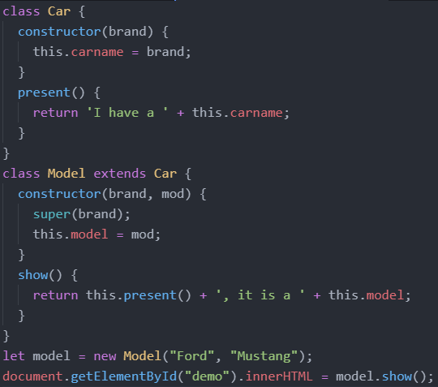

Getters and Setters

To add getters and setters in the class, use the get and set keywords.

The name of the getter/setter method cannot be the same as the name of the property, in this case carname.

Many programmers use an underscore character _ before the property name to separate the getter/setter from the actual property. Notice that setters and getter methods can have the same name.

To use a getter or setter, use the same syntax as when you set a property value, without parentheses.

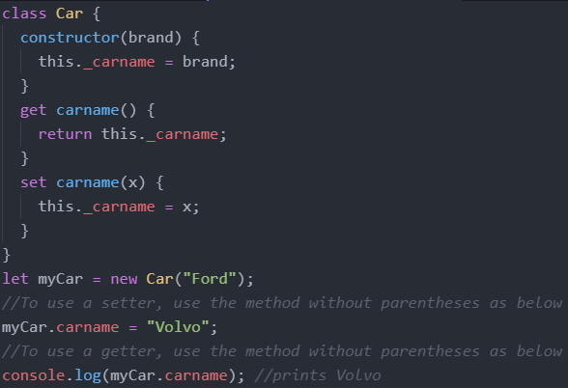

Hoisting

Cass declarations are not hoisted so you must declare a class before you can use it.

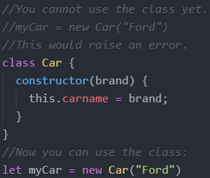

Static Class Properties and Methods

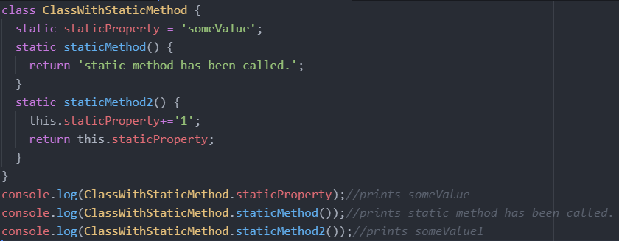

**Modules**

Modules can only be used in live servers, by directly clicking the file on our desktop.

Assume we have the following directory structure where main.js imports code from util.js.

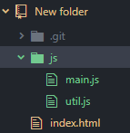

In the html, make sure to link to the main js file with type = 'module'.

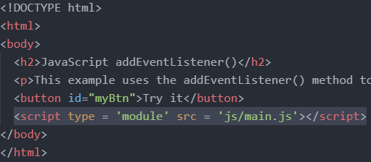

Single Export

In the utils.js file, we have the following. We have a const and function declaration as normal, but we stick the word export in front. This makes the const and function exportable.

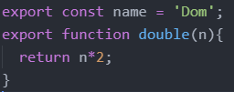

We can also do the following

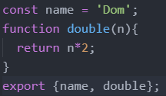

In the main.js file, we do import {item1, item2, item3, …} from 'filePath.js';

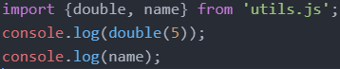

We can also change the names of imported items

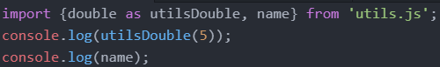

Multiple Export

We still have to put export for each thing we want to export in the utils.js file.

But in the html file, we can do * instead of listing each item we want to import.

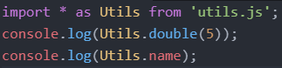

Default Export

The export default keyword means the item is the default export for the module. One module can only have 1 default export.

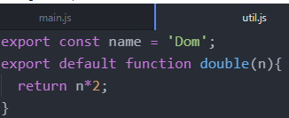

In the main.js folder, we can do the following. Notice there is no item called bottle in the utls.js module. Thus, bottle will be used for the default export which is the function.

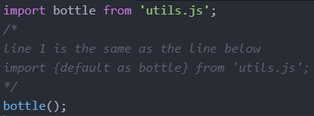

**Callbacks**

* A callback is a function passed as an argument to another function.
* This technique allows a function to call another function.
* A callback function can run after another function has finished.
* We can think of functions as variables that contains the function definition. This is what happens when you reference a function without parenthesis. You are just referencing the variable that stores the function.
* 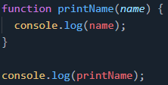 will display: 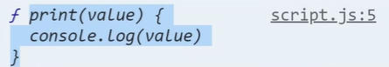
* You will notice that in the console it will show you the function definition since that is what the printName variable is storing.
* We could also display printName by using console.dir(printName) to get the following
* 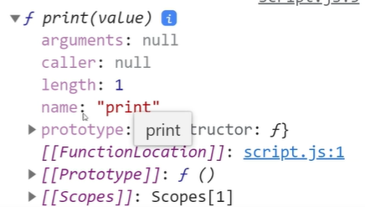
* As well, notice that the output is very much like an output. This is because a function is just a javascript object. In fact, we could even do something like the following which displays “hi” in the console.
* 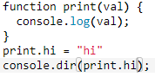
* Ex: 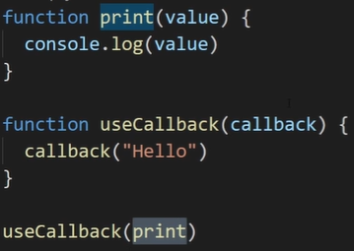
* Notice above, we defined a function called print which takes in a parameter and displays it.
* We also defined a function called useCallback which takes in a parameter called callback. In this useCallback function, we apply the apply the parameter function named callback on the string “Hello” and execute the function named callback.
* Then, we use useCallback(print) which passes the print function to the useCallback function. Notice the print function is not executed yet, it is just passed in as an argument. Then the useCallback function applies the print function on “Hello” which displays “Hello” on the console.
* We could also use an arrow function instead of naming the print function to make the code cleaner
* 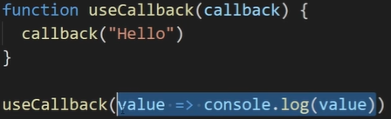
* Where callbacks really shine are in asynchronous functions, where one function has to wait for another function (like waiting for a file to load).

**Event Loop**

* <https://medium.com/front-end-weekly/javascript-event-loop-explained-4cd26af121d4>
* JavaScript is single-threaded which means it can only do 1 thing at a time in a single point in time. The JavaScript engine executes a script from the top of the file and works its way down. It pushes, and pops functions onto and off the call stack in the execution phase.

Call Stack / Blocking

* + A function that takes a long time to complete is called a blocking function. Technically, a blocking function blocks all the interactions on the webpage, such as mouse click.
  + An example of a blocking function is a function that calls an API from a remote server.
  + The following example uses a big loop to simulate a blocking function:
  + 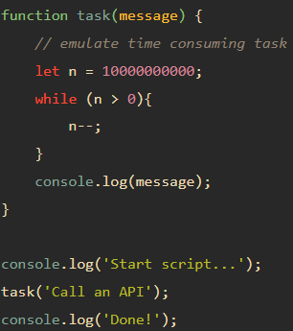
  + In this example, we have a big while loop inside the task() function that emulates a time-consuming task. The task() function is a blocking function.
  + The script hangs for a few seconds (depending on how fast the computer is) and issues the following output:
    - Start script... (this is printed immediately)
    - Call an API (this takes some time to print)
    - Done! (this is printed right after ‘Call an API’ is printed)
  + The call stack will look something like the below
  + 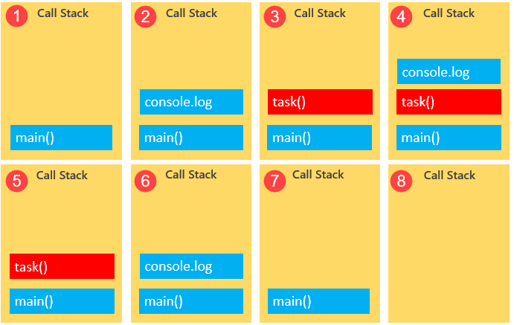
  + 1. We run the file
  + 2. We reach console.log(‘Start script’) so we add to the call stack. Then we execute the function. Then remove it.
  + 3. We add task to the call stack and execute the function. We eventually get to the console.log(message) line after a long time because of the while loop.
  + 4. We add console.log(message) to the top of the stack frame, then execute it, then remove it.
  + 5. We just removed the console.log(message) and continue executing the task function. There is nothing left to execute so we remove it
  + 6. We add log(“done”) to the stack, execute it, and remove it
  + 7. we ran all the functions in the file so now we can remove main()
  + 8. We ran everything so the call stack is empty.
* Basic Architecture
  + Call Stack — This represents the single thread provided for JavaScript code execution.
  + Browser or Web APIs are built into your web browser, and are able to expose data from the browser and surrounding computer environment and do useful complex things with it. They are not part of the JavaScript language itself, rather they are built on top of the core JavaScript language, providing you with extra superpowers to use in your JavaScript code.
  + Event or Callback Queue — It is responsible for sending new functions to the track for processing.
  + 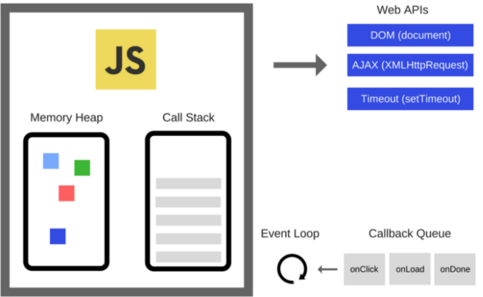
  + Asynchronous functions like setTimeout and .then for promises are sent to a web api. Then, once the async function is finished, it is sent to the event queue for processing.
  + It has one simple job — to monitor the call stack and the callback queue. If the call stack is empty, the event loop will take the first event from the queue and will push it to the call stack, which effectively runs. If it is not, then the current function call is processed.
* Ex:
  + 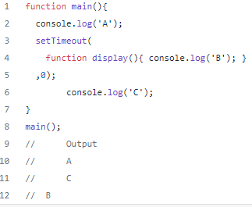
  + Here we have the main function which has 2 console.log commands logging ‘A’ and ‘C’ to the console. Sandwiched between them is a setTimeout call which logs ‘B’ to the console with 0ms wait time.
  + 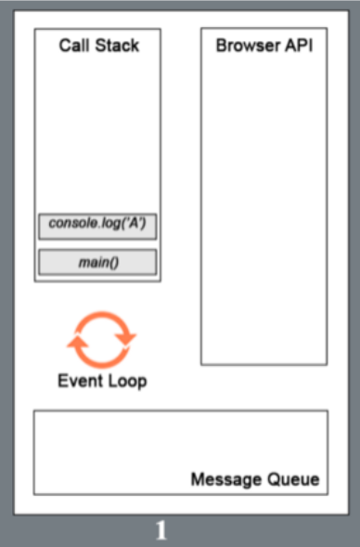
  + 1. The call to the main function is first pushed into the stack (as a frame). Then the browser pushes the first statement in the main function into the stack which is console.log(‘A’). This statement is executed and upon completion that frame is popped out. Alphabet A is displayed in the console.
  + 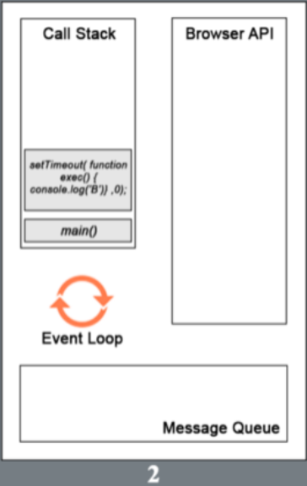
  + 2. The next statement (setTimeout() with callback exec() and 0ms wait time) is pushed into the call stack and execution starts. setTimeout function uses a Browser API to delay a callback to the provided function. The frame (with setTimeout) is then popped out once the handover to browser is complete (for the timer).
  + 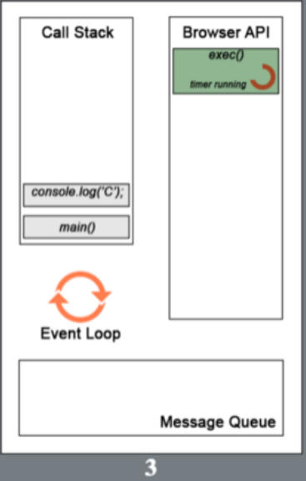
  + console.log(‘C’) is pushed to the stack while the timer runs in the browser for the callback to the exec() function. In this particular case, as the delay provided was 0ms, the callback will be added to the message queue as soon as the browser receives it (ideally).
  + 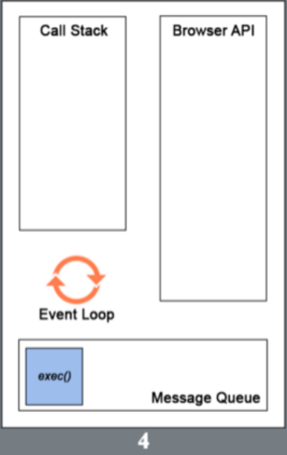
  + 4. After the execution of the last statement in the main function, the main() frame is popped out of the call stack, thereby making it empty. For the browser to push any message from the queue to the call stack, the call stack has to be empty first. That is why even though the delay provided in the setTimeout() was 0 seconds, the callback to exec() has to wait till the execution of all the frames in the call stack is complete.
  + 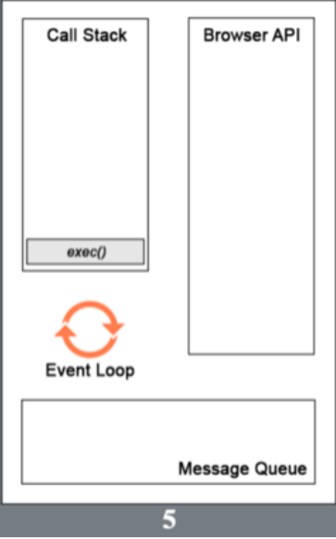
  + Now the callback exec() is pushed into the call stack and executed. The alphabet B is display on the console. This is the event loop of javascript.
* Ex:
  + 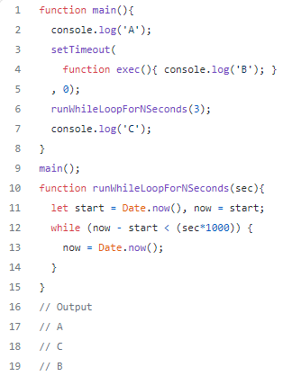
* However that is not all for the event loop, we are missing the difference between macrotasks and microtasks.
* Inside the message queue/ task queue, the functions/tasks are classified into two categories, macrotasks and microtasks.
* Microtasks
  + Examples: process.nextTick, Promises, queueMicrotask, MutationObserver
  + micro-task is said to be a function which is executed after the function or program which created it exits and only if the JavaScript execution stack is empty, but before returning control to the event loop being used by the user agent to drive the script’s execution environment. A Micro-task is also capable of en-queuing other micro-tasks.
  + On completion of one macro-task, the event loop moves on to the micro-task queue. The event loop does not move to the next task outside of the micro-task queue until the all the tasks inside the micro-task queue are completed. This implies that the micro-task queue has a higher priority. Once all the tasks inside the micro-task queue are finished, only then does the event loop shifts back to the macro-task queue.
  + In such a case wherein new micro-tasks are being added to the queue, these additional micro-tasks are added at the end of the micro-queue and these are also processed. This is because the event loop will keeps on calling micro-tasks until there are no more micro-tasks left in the queue, even if new tasks keep getting added.
* Macrotasks
  + Examples: setTimeout, setInterval, setImmediate, requestAnimationFrame, I/O, UI Rendering
  + Macro-task represents some discrete and independent work. These are always the execution of the JavaScript code and micro-task queue is empty. Macro-task queue is often considered the same as the task queue or the event queue. However, the macro-task queue works the same as the task queue. The only small difference between the two is that the task queue is used for synchronous statements whereas the macro-task queue is used for asynchronous statements.
  + In JavaScript, no code is allowed to execute until an event has occurred. It is worth mentioning that the execution of a JavaScript code execution is itself a macro-task. The event is queued as a macro-task. When a (macro) task, present in the macro-task queue is being executed, new events may be registered and in turn, created and added to the queue.
  + Upon initialization, the JavaScript engine first pulls off the first task in the macro-task queue and executes the callback handler. The JavaScript engine then sends these asynchronous functions to the API module, and the module pushes them to the macro-task queue at the right time. Once inside the macro-task queue, each macro-task is required to wait for the next round of the event loop. In this way, the code is executed.
  + All micro-tasks logged are processed in one fell swoop in a single macro-task execution cycle. In comparison, the macro-task queue has a lower priority. Macro-tasks include parsing HTML, generating DOM, executing main thread JavaScript code, and other events such as page loading, input, network events, timer events, etc.
* Ex: Using setTimeout and Promise
  + 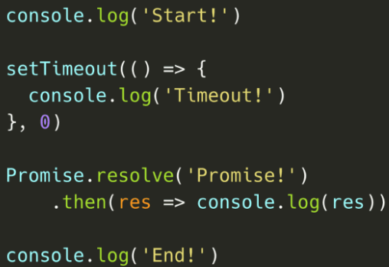
  + 
  + 1. On the first line, the engine encounters the console.log() method. It gets added to the call stack, after which it logs the value Start! to the console. The method gets popped off the call stack, and the engine continues.
  + 
  + 2. The engine encounters the setTimeout method, which gets popped onto the call stack. The setTimeout method is native to the browser: its callback function (() => console.log('Timeout!')) will get added to the Web API until the timer is done. Although we provided the value 0 for the timer, the call back still gets pushed to the Web API first, after which it gets added to the (macro) task queue: setTimeout is a macro task!
  + 
  + 3. The engine encounters the Promise.resolve() method. The Promise.resolve() method gets added to the call stack, after which it resolves with the value Promise!. Its then callback function gets added to the microtask queue.
  + Note: it’ll be easier to think the above as
  + const p1 = promise.resolve('promise')
  + p1.then(res => console.log(res))
  + 
  + 4. The engine encounters the console.log() method. It gets added to the call stack immediately, after which it logs the value End! to the console, gets popped off the call stack, and the engine continues.
  + 
  + 5. The engine sees the call stack is empty now. Since the call stack is empty, it’s going to check whether there are queued tasks in the microtask queue! And yes there are, the promise then callback is waiting for its turn! It gets popped onto the call stack, after which it logs the resolved value of the promise: the string Promise!in this case.
  + 
  + 6. The engine sees the call stack as empty, so it’s going to check the microtask queue once again to see if tasks are queued. Nope, the microtask queue is all empty. It’s time to check the (macro)task queue: the setTimeout callback is still waiting there! The setTimeout callback gets popped onto the call stack. The callback function returns the console.log method, which logs the string "Timeout!". The setTimeout callback gets popped off the call stack.

Asynchronous Vs Synchronous Programming

* The setTimeout function in the previous section in these notes (even loop) actually is a form of asynchronous programming.
* Both asynchronous and synchronous will start at the top of the file and execute all the way down to the bottom of the file.
* However, synchronous code will execute each line in order. It will always execute in the same order everytime.
* Asynchronous code will run into certain asynchronous functions/code where it will be managed by the browser API while executing the rest of the synchronous code separately but at the same time. Because the asynchronous code can take varying time to run, they are pushed into the queue at varying times. Whichever asynchronous code finished first is added to the queue first, it doesn’t matter when the asynchronous code was added to the browser api.
* 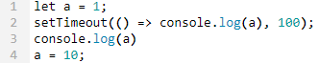 => 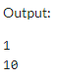
* Notice in the example above, we changed the value of a after we started the timeout. When the timeout eventually logs the value of a, it does not log out 1 which was the value of a when the timeout function started, but it logs out 10 which is the value of a when the timeout function finished. Note the result would be the same even if the timeout was for 0 seconds.
* If we wanted to change the value of a after the timer runs out, we could do the following.
* 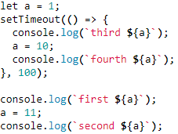=> 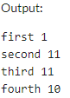

**Promise**

* A promise in JS is like a promise in real life. You commit to something by promising to do something and you either fulfill your promise (resolve) or fail to keep your promise (reject). You could also be (pending) which is when the promise has yet to be resolved or rejected.
* Promises are really good when you need to do something that takes a long time(and might fail) in the background. For example, if we have to download an image from a different server.
* In the code below, in the promise we call a function that does something(which can succeed or fail). In that function, we will also either call the resolve function if the task was successful and the reject function if the task failed. The .then method does what should happen if the resolve function was called and the .catch method does what should happen if the reject function is called.
* Line 3 creates a new Promise object which takes in a function as a parameter.
* 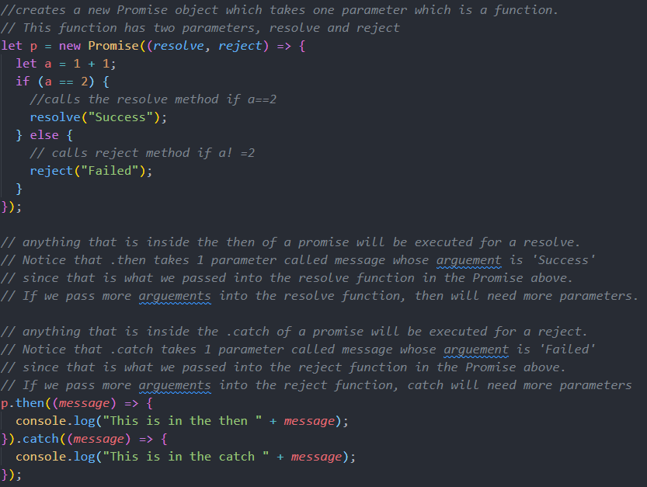
* Note that resolve and reject and not keywords. We could rename resolve to res if we wanted to, and the same applies for reject. As well, the resolve function does not need to come first. We could have new Promise ((rej, res) in line 3 but that just means we would have to switch the order in which the res/rej functions are passed in (line 27 – 31).
* Note that in the example above, message is not a key word. It is just the name we decided to the parameter of the function.
* Creating a promise object is synchronous
  + Ex:
    - 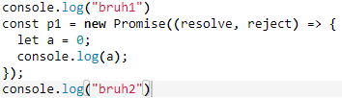 => 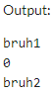
  + Ex:
    - 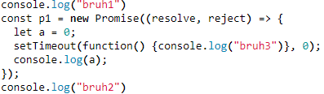=> 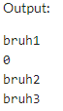
    - Since we used Timeout, “bruh3” will be displayed last even thought it was timedout for 0 seconds.
  + Ex:
    - 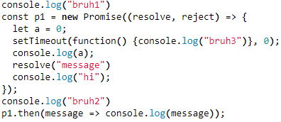=> 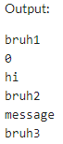
  + Ex:
    - 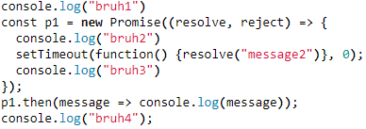=> 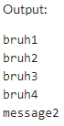
    - Note that p1.then runs only after p1 is resolved (the entire purpose of promises is that we gotta wait until we get a response, either resolve or reject). Thus, only after the setTimeout is pushed into the call stack from the task queue and resolves p1 is p1.then going to be added to the microtask q.

Consuming a promise object using .then and .catch is asynchronous

* + Ex:
    - 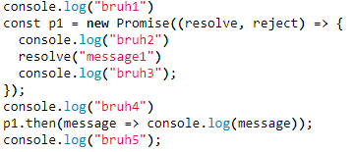=> 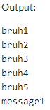
    - Since we did .then which is asynchronous, message1 was displayed after bruh5
  + Ex:
    - 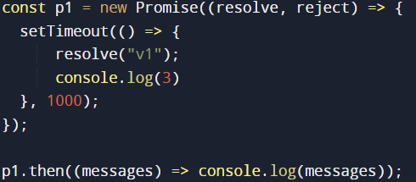=> 
    - 3 is printed first when we have the setTimeout(), the resolve(“v1”) is pushed into the task queue first, and then console.log(3) is pushed into the microtask queue. When we use .then, then console.log(messages) is pushed into the queue. Since console.log(3) is in the micro queue, it’s printed first.
* Ex:
* 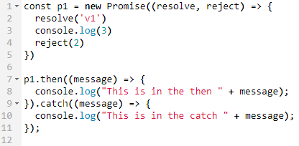=> 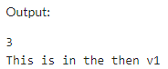
* Note if we don’t have a resolve/reject in the Promise and there will be no error.
* 
* Note that if we don’t have .then and .catch, it is possible we don’t get an error. We get an error if the promise is rejected and we try to use a .then without including a .catch. The opposite is true as we get an error if the promise is resolved and we try to use a .catch without including a .then
* We can have many resolves, the first resolve will be the resolve of the promise.
* Ex:
  + 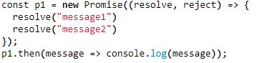=> 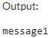
  + 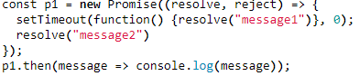 => 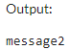
  + Notice since we used setTimeout which is asynchronous, the resolve is message2 and not message1 even though we timedout for 0 seconds.
* Ex:
  + 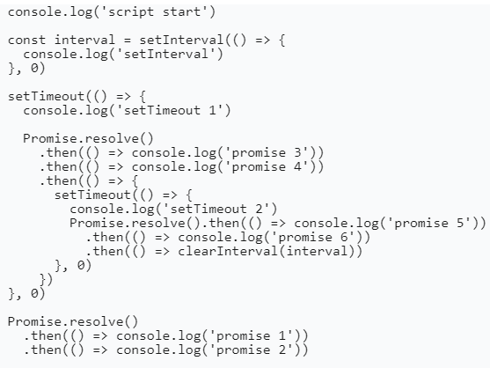=>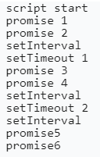
  + No clue above, <https://www.linkedin.com/pulse/javascript-under-hood-microtasks-macrotasks-eliran-elnasi/>
* Promises are meant to replace callbacks
* Consider the following code with callbacks.
* 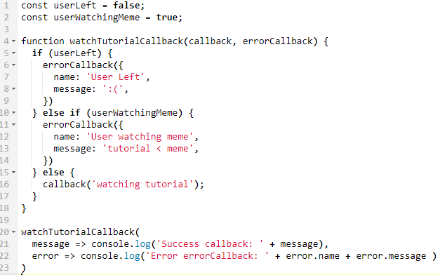
* In line 4 we declare a function that takes in two parameters, callback and errorCallback (which will both be functions). If userLeft, we will execute the errorCallback function and pass in the { name: 'User Left', message: ':(',} object as a parameter. If userWatchingMeme, we will execute the errorCallback function and pass in the { name: User watching meme', message: ' tutorial < meme',} object as a parameter. Otherwise, we will execute the callback function and pass in the ‘watching tutorial’ string as a parameter.
* In line 20, we execute the watchTutorialCallback function we declared above. To execute this function, we pass in two parameters, the first being a function that will be the value of the callback parameter and the second being a function will be the value of the errorCallback parameter. Because useLeft is false, the output will be the following:
* 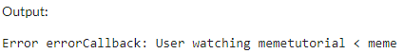
* We could replace the above code by using promises instead of callbacks as shown below.
* 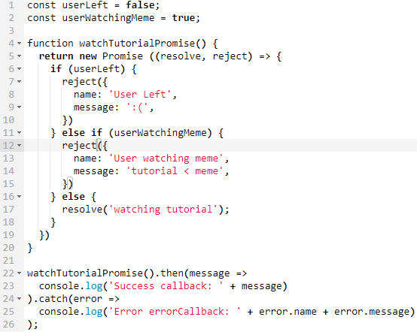
* Promise.all
  + 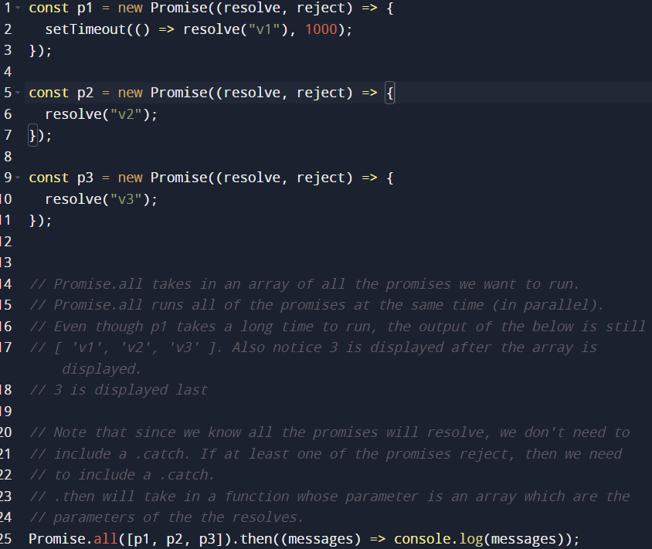
  + Output:
  + 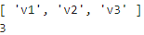
* Promise.race
  + Promise.race is the same as promise.all except it’ll return as soon as the first promise is completed instead of waiting for all the promises to complete. Because of that, it’ll only return 1 resolve parameter instead of an array of resolve parameters.
  + 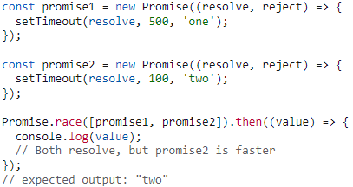
  + Ex:
    - 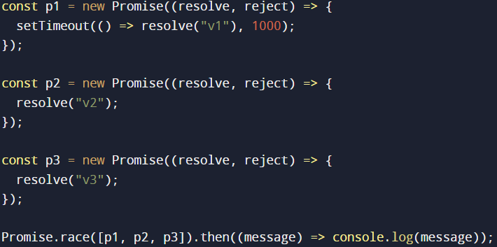
    - Output: v2

**Async Await**

* Different syntax that can replace promises and make it look cleaner
* Consider the following:
* 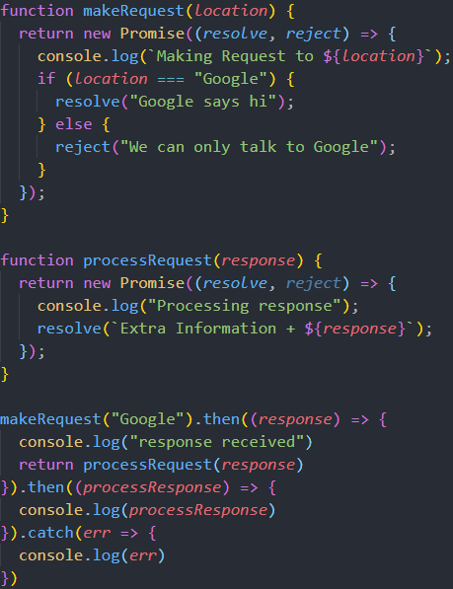 =>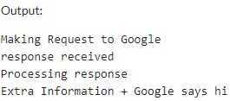
* We can make the above code cleaner, specifically the last part. We can get rid of the chaining of .then
* To do so, we use async await.
* An async function is a function that knows how to expect the possibility of the await keyword being used to invoke asynchronous code.
* await only works inside async functions
* await can be put in front of any async promise-based function to pause your code on that line until the promise fulfills, then return the resulting value.
* You can use await when calling any function that returns a Promise
* Once JS hits the await keyword, makeRequest is passed to the web api in the event loop. Then JS continues with the rest of the synchronous code.
* An async function always returns a promise
* Now we can rewrite the code to use async await instead of promises
* 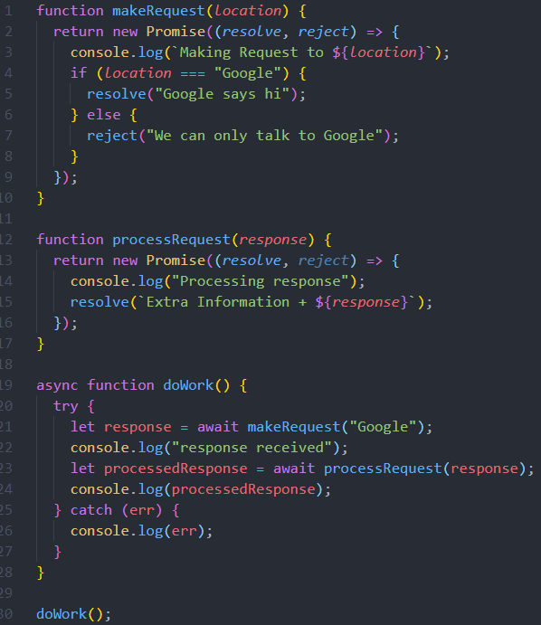
* Notice the only change is at the end
* 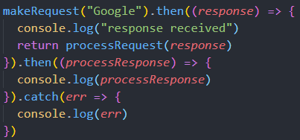Vs 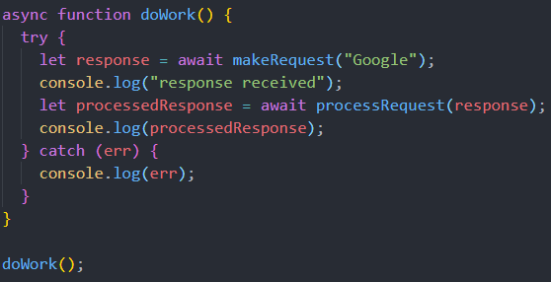
* We could also use arrow functions to make it the following
* 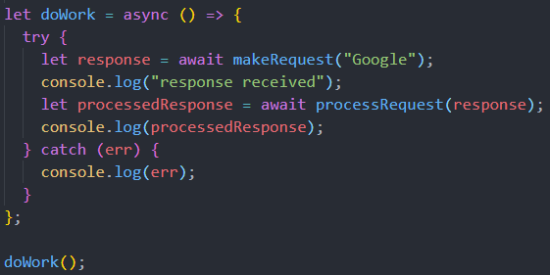
* **Async Await Event Loop (THIS SECTION IS HELLA SKETCHY)**
* When we execute an async function,
* When we reach the word async, the function that is being await gets executed. (if the await is really fastRight after, the rest of the async function is pushed to the microtask. Then go out of the async function and go to the rest of the synchronous code.
* Ex: 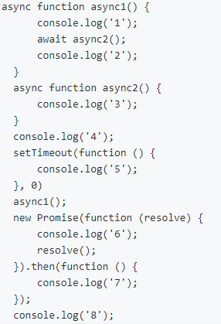=> 
* Ex: 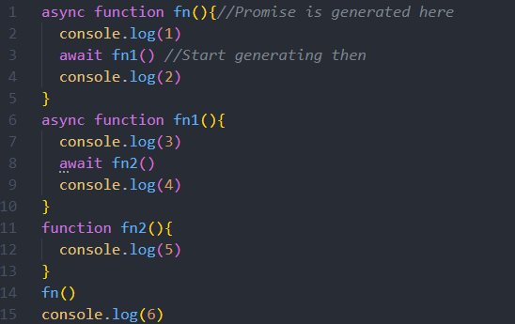=> 
* Ex:
  + 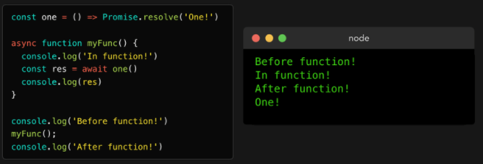
  + 1. First, the engine encounters a console.log. It gets popped onto the call stack, after which Before function! gets logged.
  + 2. Then, we invoke the async function myFunc(), after which the function body myFunc runs. myFunc is pushed into the stack. On the very first line within the function body, we call another console.log, this time with the string In function!. The console.log gets added to the call stack, logs the value, and gets popped off.
  + 3. The function body keeps on being executed, which gets us to the second line. The first thing that happens is that the value that gets awaited gets executed: the function one in this case. One gets popped onto the call stack, and eventually returns a resolved promise, and gets popped out. Before the promise has resolved, the engine encounters the await keyword.
  + When encountering an await keyword, the async function myFunc gets suspended. The execution of the function body gets paused. The rest of the async function gets pushed into the microtask queue.
  + Now that the async function myFunc is suspended as it encountered the await keyword, the engine jumps out of the async function and continues executing the code in the execution context in which the async function got called: the global execution context in this case
  + Console.log(‘After function’) is pushed onto the stack, printed, then popped off
  + Finally, there are no more tasks to run in the global execution context! The event loop checks to see if there are any microtasks queued up: and there are! The async myFunc function is queued up after resolving the valued of one. myFunc gets popped back onto the call stack, and continues running where it previously left off.
  + The variable res finally gets its value, namely the value of the resolved promise that one returned! We invoke console.log with the value of res: the string One! in this case. One! gets logged to the console and gets popped off the call stack!
* Ex:
  + 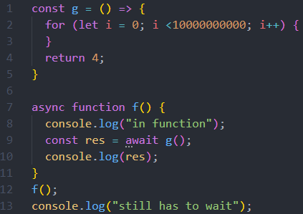=> 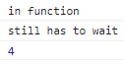
  + This example is the same as the above except we made the function that is being awaited take very long to execute with a for loop.
  + F is pushed onto the call stack and executed
  + ‘In function’ is pushed onto the call stack, immediately printed, then poppped
  + We pop g onto the call stack, execute g() which takes a long time, then pop it
  + We then encounter the await keyword. The rest of f is pushed into the micro q task and f is popped.
  + Then we continue to the rest of the synchronous code
  + Console.log(‘still has to wait’) is pushed onto the stack, printed (it took a while to print since we waited on g), then popped off
  + After the call stack is empty, the microtasks are pushed onto the call stack.
  + Res now gets its value of 4 and ‘4’ is immediately printed right after ‘still has to wait’
* Ex: BAD EXAMPLE
  + 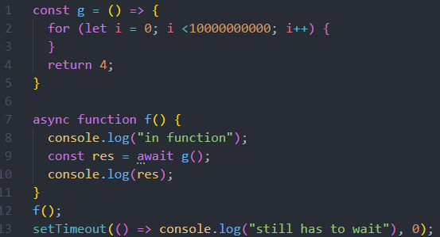=> 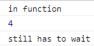
  + F is pushed onto the call stack and executed
  + ‘In function’ is pushed onto the call stack, immediately printed, then poppped
  + We pop g onto the call stack, execute g() which takes a long time, then pop it
  + We then encounter the await keyword. The rest of f is pushed into the micro q task and f is popped.
  + Then we continue to the rest of the synchronous code
  + We then push to setTimeout function into the call stack. The console.log(“still has to wait”) is pushed into the web api. Then setTimeout function is popped. Since the time for setTimeout was 0, console.log(“still has to wait”) is immeiditly pushed into the macrotask queue.
  + Now, the call stack is empty.
  + Since microtasks have greater priority than macrotasks, microtasks (in this case the rest of f) is executed.
  + Then once all the microtasks are done, the macrotask “still has to wait” is printed.
* Ex:
  + 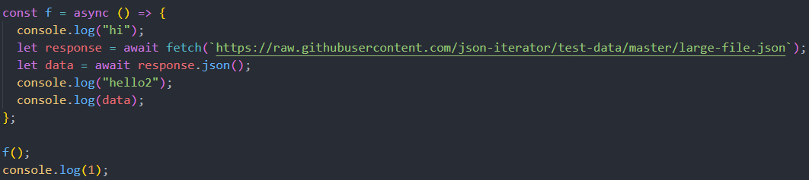
  + 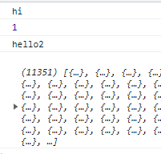
  + When we call f, the line console.log(“hi”) is synchronous so that is immediately logged. When we get to fetch(), it is executed. Before it is done executing, we then encounter the await keyword. At this point, the rest of the function () is pushed into the micro queue.
  + Since we encountered the await keyword, we continue to the rest of the synchronous code which is console.log(1) which gets logged.
  + We eventually wait for fetch to finish.
  + Now the call stack is empty but there are microtasks(the rest of f)
  + When we get to .json(), it is executed.
* Ex:
  + 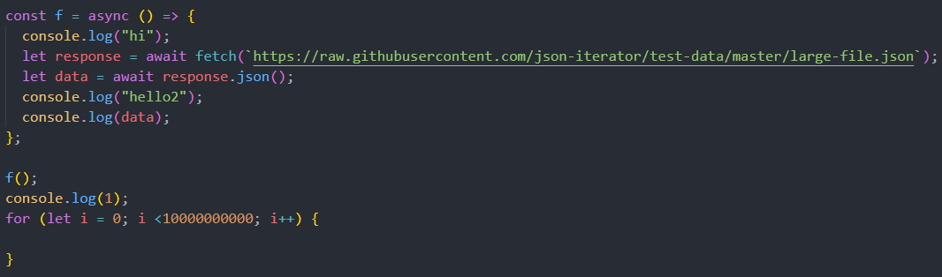
  + 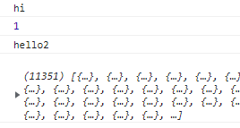
  + When we call f, the line console.log(“hi”) is synchronous so that is immediately logged. When we get to response which has await, the function becomes asynchronous. At this point, the rest of the function () is pushed into the microtask queue.
  + Thus, we continue to the rest of the synchronous code which is console.log(1) which gets logged.
  + Then we wait a while because of the for loop.
  + The second the loop ends, we immediately log hello2 and data.

**Fetch API**

* REST API lets you push and pull data from a datastore. There are a few different types of REST APIs. Let’s look at the ones you will use in most cases.
  + GET — Get data from the API. For example, get a twitter user based on their username.
  + POST — Push data to the API. For example, create a new user record with name, age, and email address.
  + PUT — Update an existing record with new data. For example, update a user’s email address.
  + DELETE — Remove a record. For example, delete a user from the database.
* There are three elements in every REST API. The request, response, and headers.
* Request — This is the data you send to the API, like an order id to fetch the order details.
* Response — Any data you get back from the server after a successful / failed request.
* Headers — Additional metadata passed to the API to help the server understand what type of request it is dealing with, for example “content-type”.
* Fetch lets you work with REST APIs with additional options like caching data, reading streaming responses, and more.
* The fetch api takes in two parameters. The first is the url that you are accessing. The second is optional is all the different options such as method, headers, request body, so on.
* Fetch returns a promise which means we can use async await or .then/.catch with it.
* When we display the response from the promise, we get an object
* 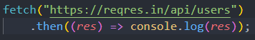
* 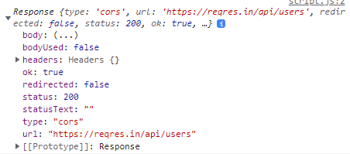
* Note that status = 200 and ok = true which means we good.
* However, this object’s body field is not accessible yet, we need to convert it to json.
* Thus, we will say res.json() which returns another promise.
* 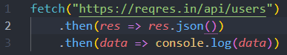
* 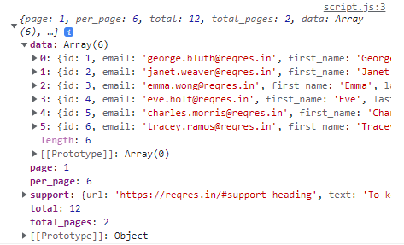
* Now, we get all of this data which we can use.
* We can also specify just getting the first user by adding /1 to the path of the url.
* 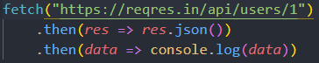
* 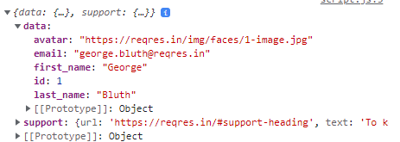
* What if we try to access a user that doesn’t exist
* 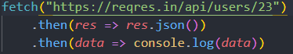
* 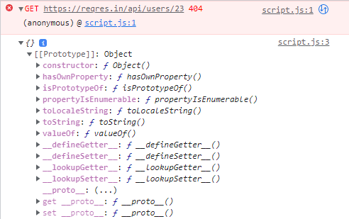
* Notice a 404 error is raises but both promises (the fetch and json) were resolved which is why the data got displayed. We would think 404 is an error and we would need a catch statement. However, fetch always resolves no matter what. The only case where fetch is rejected is if there is a network error where the browser can’t connect to the internet. Fetch does not reject if the api we are calling does not exist.
* However, this is likely not what we want since we probably want when the response is good.
* Thus, we can check if the response is ok by accessing the ok field of the object that fetch returns.
* 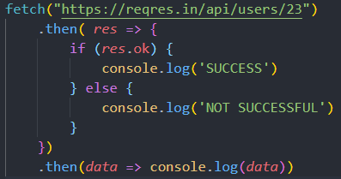
* Now if we try to get a user that doesn’t exist, it displays not successful
* 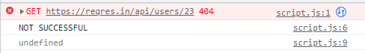
* However, what if we want to post data and not just get it.
* Then we need to add the second parameter to the fetch api.
* Do note that the request body should be a JSON string while the headers should be a JSON object.
* 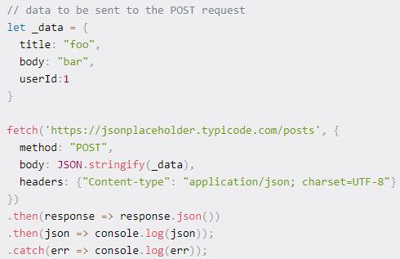

Cookies, Local Storage, SessionStorage

* 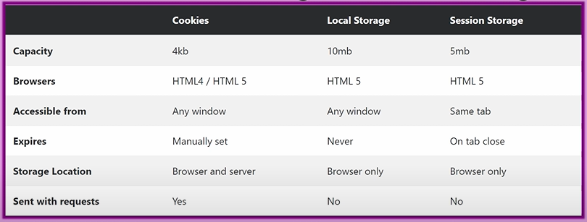
* All of the data stored in any of the three are stored in a specific browser such as Google Chrome. Thus, any data is stored in Chrome won’t be available in other browsers such as Firefox.
* Also, the data is specific to a specific user’s computer, no one else can access the data stored in cookies/local/session storage.
* Information stored in local storage should not be important since it can easily be lost.
* Notice we can see the data stored in cookies/local/session storage by inspecting, going to application and clicking the storage below.
* 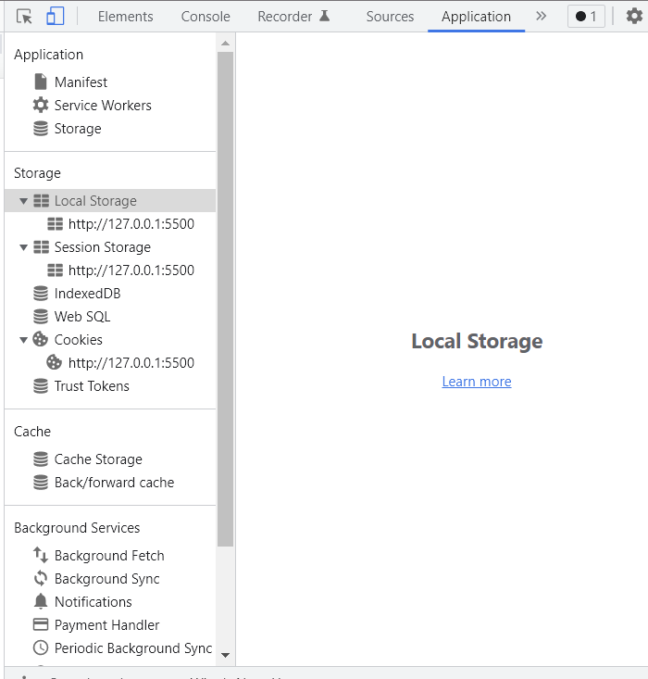
* Note that inside the session storage, there will already be something inside it since I am using Live Server VS Code extension to make these notes.
* 
 